Math 3 Trigonometry Review Unit 7

**Find the measure of an angle between 0º** **and 360º coterminal with each given angle.**

**1.** −323° **2.** −4° **3.** 370°

**Sketch each angle in standard position.**

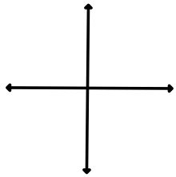**4.** 15° **5.** −230° **6.** 395°

**Write each measure in radians. Express the answer in terms of** π.

**7.** 315° **8.** −450° **9.** 210°

**Write each measure in degrees. If necessary, round your answer to the nearest degree.**

**10.  11.  12.** 6π

**Find the exact values of cos*θ*** , **sin*θ*** , **and tan*θ*  for each angle measure.**

**13.** −120° **14.** 135° **15.** radians

**Write a cosine function for each description.**

**16.** amplitude = , period = 2, *a* > 0 **17.** amplitude = 3, period = *a* < 0

**Write an equation for each translation.**

**18.** *y* = cos *x*, 4 units to the left **19.** *y* = sin *x*,  units right, 2 units up

**20. Complete the identities.**

$\csc{θ=\frac{1}{ }}$ $\sec{θ=\frac{1}{ }}$ $\cot{θ=\frac{ }{ }}$ $\tan{θ=\frac{ }{ }}$

**Evaluate each expression. Write your answer in exact form. If the expression is undefined, write *undefined*.**

**21.** sec (−30°) **22.** csc 270° **23.** cot 210° **24.** sec 90°

**Find the amplitude and period of each function. Then sketch one cycle of the graph of each function. Show all work (including tables!).**

**25.** *y* = 3 sin 4*x* **26.** *y* = -2 cos

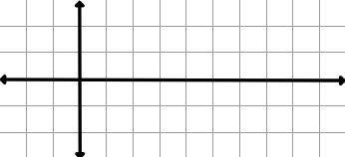

**27.** *y* = cos (*θ* – 3) + 2

**28.** *y* = -sin



**29.** In Johannesburg in June, the daily low temperature is usually around 3◦C, and the daily high temperature is around 18◦C. The temperature is halfway between the daily high and the daily low at both 10 am and 10pm, and the highest temperatures are in the afternoon. Write a trigonometric function that models the temperature T in Johannesburg t hours after midnight. Graph the function on the coordinate plane.

**30.** A Ferris Wheel has a diameter of 24 feet and is 4 feet off the ground. It rotates once every 30 seconds.

a) Write a trigonometric equation that represents this situation.

b) How high was the Ferris wheel after 45 seconds?

c) At what time did the Ferris wheel first reach 24 feet?