STATION #1:
Geometric Properties

1. Find the values of x and y in the picture.
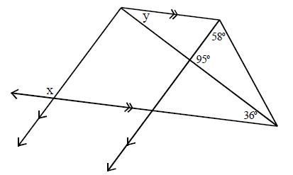

2. Find the values of q, r, and s in the picture.
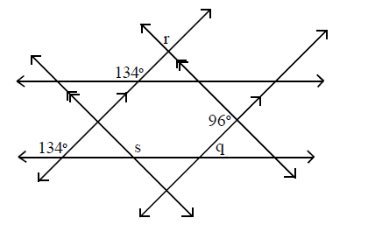

3. Draw and label a picture to represent the following:
- Line WZ includes points X and Y so that X is the midpoint of segment WY and Y is the midpoint of XZ.
- Angles WXA and BXY are obtuse vertical angles.
- Angles AXY and YXC are complementary.
- BXC is a right angle.
STATION #2:
Triangle Congruence

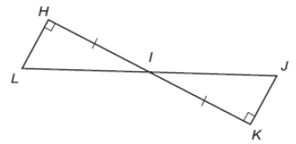
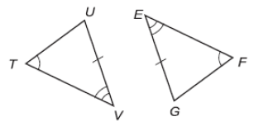
Determine whether each pair of triangles is congruent. If so, write a congruence statement and explain why the triangles are congruent. If it is not possible, write not possible.

1.
2.
3.

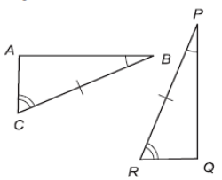
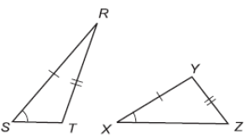
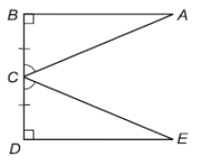

4.
5.
6.

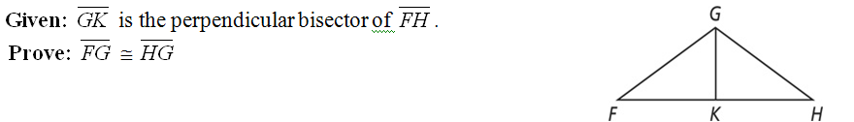
Write a two column proof.
4.

STATION #3:
Parallelograms

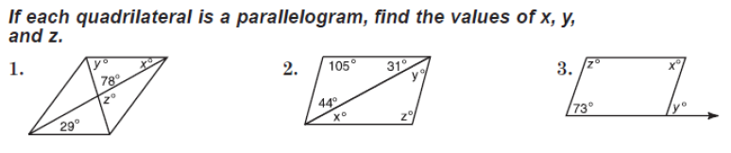

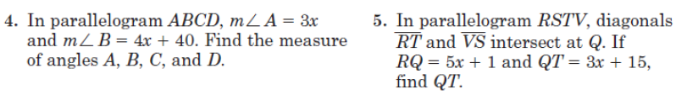

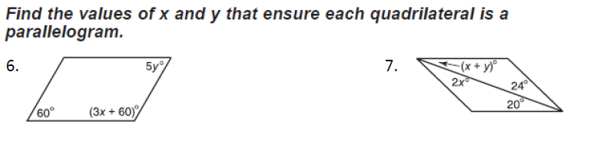

STATION #4:
Similar Polygons
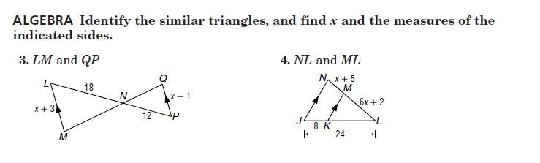

5. Chris wants to reduce a triangular pattern with sides 16, 16, and 20 centimeters. If the longest side of the new pattern is to be 15 cm, how long should the other two sides be?

6. A 9-foot ladder leans against a building six feet above the ground. At what height would a 15-foot ladder touch the building if both ladders for the same angle with the ground?

STATION #5:
Parallel Lines and Transversals

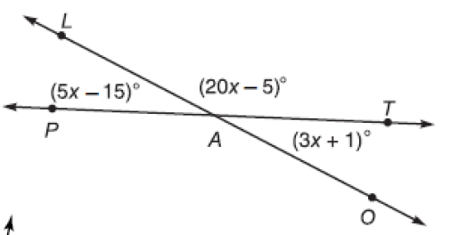
- Use the figure to find:
  - x =
  - m$∡$LAT
  - m$∡$TAO
  - m$∡PAO$

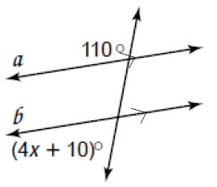
- Find x.

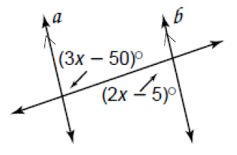
- Find x.

STATION #6:
Proofs

- 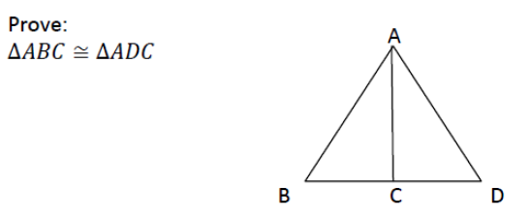

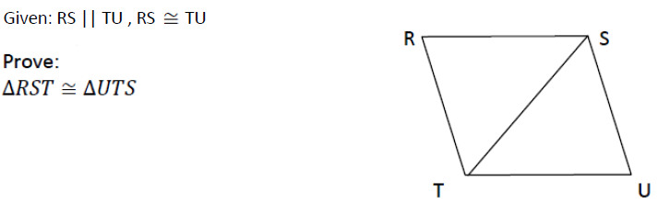

STATION #7:
Volume and Surface Area

- What is the volume of a square pyramid with side length (x-3) and height of (9x)?

- Find the volume and surface area:
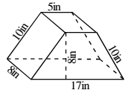
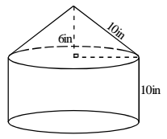

- A cylinder and a cone have the same base and equal volumes. If the cylinder is 15 inches tall, how tall is the cone?

- Review: Find the area for each of the following.

