For questions 1-2, find the perimeter. | For questions 3-4, find the missing side length.
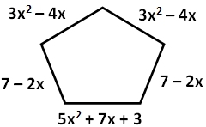 | 3. A triangle has a perimeter of 10a + 3b + 12 and has sides of length 3a + 8 and 5a + b, what is the length of the third side?
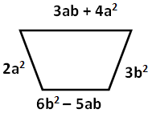 | 4. A rectangle has a perimeter of 12y² – 2y + 18 and has a width of 4y² – y + 6. What is the length of the rectangle?

For question 5, find the shaded area. | For question 6, find the volume as a polynomial.
5.  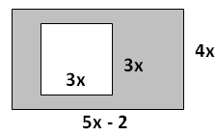 | 6. What is the volume of a square pyramid with side length (x-3) and height of (9x)?

For questions 7-8, solve the following regarding population density.
7. There is an island located off the coast of South America that is approximately 4500 sq. miles and contains 608,000 inhabitants. According to the previous year’s hospital records 11,275 children were born last year, but 9850 inhabitants died. The local government of the island believes that they can support a population that is as dense as 135 people per square mile. Given last year’s medical records can the government support the new population? | 8. A skating rink in the shape of a circle has a diameter of 160 ft. The owner of the rink realized there were more injuries on the rink floor when the population density increased. On any given Saturday, he found that at 2 PM the population density was at 0.0096 people/ft², and at 6 PM, there were 265 people out in the rink. Was it more dangerous to be on the rink at 2PM or at 6 PM? How do you know? (Use π button).

For questions 7-3, find the area.
11.  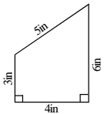 |  |  | 12.  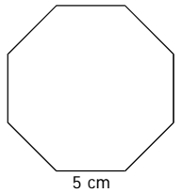 |  |  |  | 13.  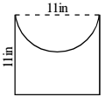
For questions 14 and 15,  Find the area of the shaded region. |  | 14. |  | 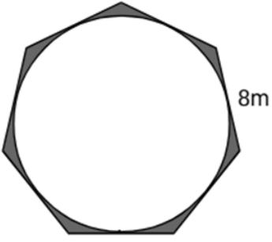 |  | 15. |  |  | 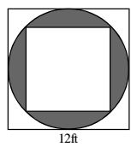
For questions 16-18 , find the volume. |  |  |  |  | Answer the following questions 19-22.
16. 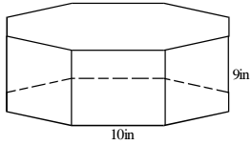 |  | 17.  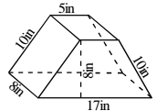 |  |  | 19. The volume of a cone is 3in³. What would be the volume after each modification below?  a. Double the radius only.  ________________  b. Triple the height only.  ________________  c. Double the height and  triple the radius.  ________________  d. Increase the height and  radius by 50%.  ________________ |  |  | 21. Challenge: The volume of the regular dodecahedron below with an edge length of 4-inches is about 490 in³. What would be the volume of a regular dodecahedron whose edges are a foot long?  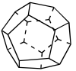
18. | 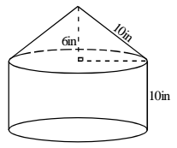 |  |  |  | 20. If you want to double the volume of a cube, by what percent should you increase the edge length?  a.20% b.23% c.26% d.30% e.40% |  |  | 22. A cylinder and a cone have the same base and equal volumes. If the cylinder is 15 inches tall, how tall is the cone?

