Math 3 Polynomials Study Guide Unit 4

**Write each polynomial function in standard form. Then determine the end behavior of each.**

1. *n* = 4*m*2 − *m* + 7*m*4

2. *f*(*t*) = 4*t* + 3*t*3 + 2*t* − 7

3. *f*(*r*) = 5*r* + 7 + 2*r*2

**Divide using long division for #s 4 and 5:**

4. (*x*3 + 3*x*2 − *x* − 3) ÷ (*x* − 1)

5. (2*x*3 − 6*x*2 + 4*x* + 1) ÷ (*x2* +3)

**Divide using synthetic division for #s 6 and 7:**

6. (2*x*3 − 3*x*2 − 18*x* − 8) ÷ (*x* − 4)

7. (6*x*3 − *x*2 + 8) ÷ (*x* + 2)

**Find all factors and solutions of each equation. Sketch a graph and state the end behavior.**

8. f(x) = *x*4 + 14*x*2 − 32 Factors: Roots: Graph:

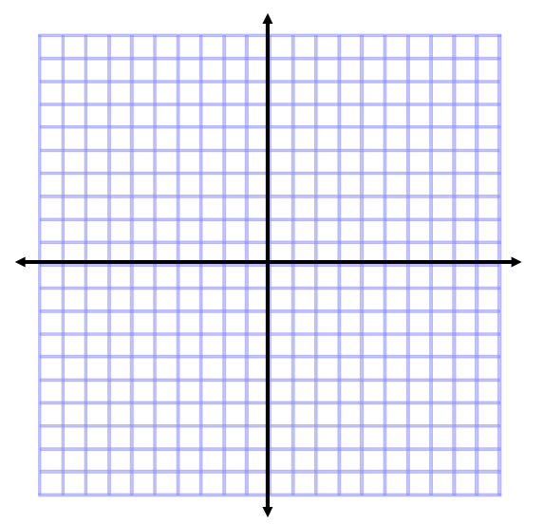

9. f(x) = *x*3 − 6*x*2 + 8x Factors: Roots: Graph:



10. f(x) = 6*x*3 − 2*x*2 − 4x Factors: Roots: Graph:



12. f(x) = *x*3 − 3*x*2 + 4*x −* 12 Factors: Roots: Graph:



**Use the given factor to factor and find all roots of the given polynomial. Sketch a graph and state the end behavior**.

13. f(x) = 3*x*4 − *x*3 − 22*x*2 + 24*x* Factor: (x – 2) Roots: Graph:



14.  Factor: (x – 2) Roots: Graph:



15.  Factor: (x + 5) Roots: Graph:



16. When you divide ${P\left(x\right)=x}^{3}+4x^{2}-2x+k$ by $\left(x-2\right)$, the remainder is 4. What is the remainder of P(x) when you divide by ?

17. Write the equation of a polynomial function that has zeros at −3 and 2 ± *i*.

18. Write the equation of a polynomial function that has zeros at ¼ and ±5i.

19. The volume of a box is *x*3 + 4*x*2 + 4*x*. Explain how you know the box is not a cube.

20. You are drawing a rectangle with side lengths of (3 – x) inches and (x – 7) inches. What is the maximum area that can be obtained from this drawing? What is the value of x that will maximize this drawing? What is the reasonable domain for the area of this rectangle?

**Expand and simplify each binomial.**

21. (*x* − 1)3

22. (3*x* + 2)4

23. (4*x +* 10)3