|  |  |
| --- | --- |
| **Unit 1** | **Review 1.1-1.3** |

**Jim and Mary have at most $20 to spend on their dinner date. They plan to buy two sodas at $1.50 each, and a pizza.**

**A plain cheese pizza costs $8 and each additional topping is $0.25.**

|  |  |  |  |
| --- | --- | --- | --- |
| 1. | Write an inequality to represent the scenario. | 2. | What is the maximum number of toppings they could order? |

**Mark needs at least $10,000 for his freshman year of college. He already saved a total of $5,000 and is earning $10 per hour at his part time job.**

|  |  |  |  |
| --- | --- | --- | --- |
| 3. | Write an inequality to represent the scenario. | 4. | At least how many hours must he work so that he can afford his freshman year of college? |

|  |  |  |  |
| --- | --- | --- | --- |
| 5. | Jenny has gotten an 85, 95, and 80 on her first three math tests. She only needs to take the quarter test which counts double a Chapter test. What grade must she earn on the quarter test in  Order to get a overall quarter grade of a 89.6? | 6. | Jenny has gotten an 80, 90, and 98 on her first three math tests. She only needs to take the quarter test which counts double a Chapter test. What grade must she earn on the quarter test in order to get a overall quarter grade of a 91.6? |

Equations / Inequalities



7. 8.

9. 10.



11. 12.

Translate & Solve

|  |  |  |  |
| --- | --- | --- | --- |
| 13. | 12 less than twice the difference of *n* and 10  is 28. | 14. | 14 less triple the sum of *n* and 8 is 4 times the difference of *n and 13*. |

|  |  |  |  |
| --- | --- | --- | --- |
| 15. | The average rainfall in Smithtown is 40 inches per year, plus or minus 10 inches. Write and solve an absolute value inequality to determine the largest and smallest rainfall the town might expect. | 16. | Write the equation of the absolute inequality that matches the graph below. |

|  |  |
| --- | --- |
| Unit 1 | **Review 1.4-1.6** |

|  |  |  |  |
| --- | --- | --- | --- |
| 1. | Two angles form a linear pair. If the larger angle is 2 more than 5 times the smaller angle. Find the measure of each angle | 2. | Find the value of x and determine the measure of each angle. |

|  |  |  |  |
| --- | --- | --- | --- |
| 3. | Two adjacent angles have a total sum of 50°. If the larger is 10 less than 5 times the smaller, find the measure of each angle. | 4. | Find the value of x and determine the measure of each angle. |

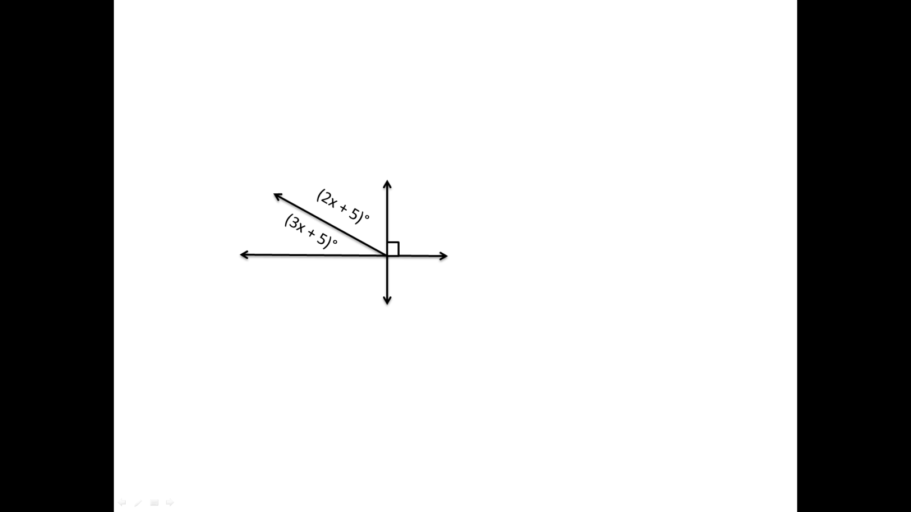

**Write both the simplified radical and decimal approximate (to the 10th) for the problems below**

|  |  |  |  |
| --- | --- | --- | --- |
| 5. | A 12 foot ladder is leaned against a wall. If the ladder reaches 10 feet up the wall, how far is the base of the ladder from the wall? | 6. | Jose lives 6 blocks east and 2 blocks south of Central station. Marcus lives 6 blocks west and 1 block north of Central Station. How far apart do Jose and Marcus live apart? (shortest distance measured in blocks) |

**Find the next 3 numbers in the pattern. Write a NEXT-NOW equation to match the sequence.**

|  |  |  |  |
| --- | --- | --- | --- |
| 7. | 12, 9, 6, 3 …. | 8. | 5, 23, 113, 563, … |

**Write an algebraic proof for the follow.**

|  |  |  |  |
| --- | --- | --- | --- |
| 9. | 14 – 2(x + 5) = 28 (Given) | 10. | 12x – 2(x – 6) + 10 = 102 (Given) |