Math 3 Unit 5 Study Guide Unit 5

***Directions:* Sketch the asymptotes and the graph of each function. Identify the domain.**

1. 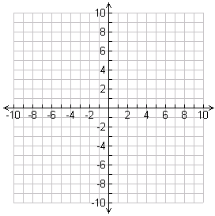 
2. 
3. 

***Directions:* Find points of discontinuity, the domain, horizontal and vertical asymptotes, and x-intercepts.**

1. 
2. 



**Simplify. State any restrictions on the variables.**

1. 
2. 
3. 
4. 
5. 
6. 
7. 
8. 

**Simplify each sum or difference. State any restrictions on the variables.**

1. 
2. 
3. 
4. 
5. 
6. 

**Solve each equation. Check each solution.**

1. 
2. 
3. 
4. 
5. 
6. 