**Unit 7 Rational Expressions Exam Review Unit 7 Review**

***Directions:* Sketch the asymptotes and the graph of each function. Identify the domain and the range.**

1. 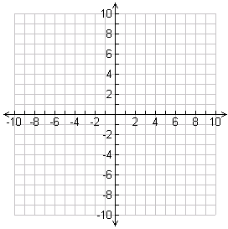 
2. 
3. 

***Directions:* Find points of discontinuity, the domain, and *x-* and *y*-intercepts of each rational function.**

1. 
2. 



**Simplify. State any restrictions on the variables.**

1. 
2. 
3. 
4. 
5. 
6. 
7. 
8. 

**Simplify each sum or difference. State any restrictions on the variables.**

1. 
2. 
3. 
4. 
5. 
6. 

**Solve each equation. Check each solution.**

1. 
2. 
3. 
4. 
5. 
6. 
7. It would take an apprentice house painter 1.5 h longer than his supervisor to paint an apartment. If they work together, they can complete the job in 4 h. About how long would it take the apprentice to complete the job working alone? Round your answer to the nearest tenth of an hour.
8. A master roofer can cover a garage in 1 h less than her new assistant. If they work together, they can complete the job in 7.75 h. How long would it take the assistant to complete the job working alone?