Unit 3: Study Guide Name: _________________________

Math 3

**Without graphing, determine whether each equation represents exponential growth or exponential decay. Then find the rate of growth or decay and the initial amount (y-intercept).**

**1.** *y* = 0.5(1.67)*x* **2.** *y* = 1.14*x* **3. ****4.** *y* = 4.1(0.72)*x*

1. Mr. Andersen put $1000 into an account that earns 4.5% annual interest. The interest is compounded annually and there are no withdrawals. How much money will be in the account at the end of 30 years?
2. A manufacturer bought a new rolling press for $48,000. It has depreciated in value at an annual rate of 15%. What is its value 5 years after purchase? Round to the nearest hundred dollars.

1. You place $900 in an investment account that earns 6% interest compounded continuously. Find the balance after 5 years.

**Graph each function as a transformation of its parent function. Identify the end behavior, asymptote, domain, and range.**

**8.** *f(x)* = 3*x* −1 **9.** *f(x)* = (2)*x*−2 + 2 **10**. *f(x) =* log 4 (*x +* 1)

Asymptote: Asymptote: Asymptote:

Domain: Domain: Domain:

Range: Range: Range:

f-1(x) = f-1(x) = f-1(x) =

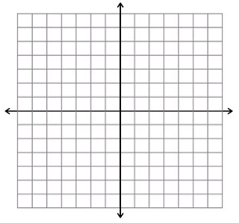

**Write each equation in logarithmic form.**

**11.** 100 = 102 **12.** 93 = 729 **13.** 64 = 43

**Evaluate each logarithm.**

**14.** log 1000 **15.** log4 256 **16.** log27 9

**Solve each equation.**

**17.** log3 (*x* + 1) = 4 **18. **

**19.** log *x* + log 2 = 5 **20.** ln *x* − ln 4 = 7

**21**. ${ 6}^{3x+2}=18$**22.** *e*3*xe2x* = 20

**24**. $5e^{2x}-1=9$**25**. log 3 + log x = log 12

**26.** Radium has a half-life of 1660 years. If the initial amount of radium is 200 grams, how much will remain after 500 years?

**Simplify.**

**27. $ln e^{6}$ 28. $e^{ln 3}$**   **29. $\log_{2}2$ 30**. $3^{\log_{3}8}$