Unit 2: Functions and Their Inverses Name: __________________________
Math 3 Study Guide

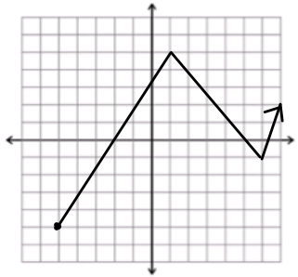
- Identify the following from the graph shown below.

  - Domain:
  - Range:
  - X-intercept(s):
  - Y-intercept(s):
  - Intervals increasing:
  - Intervals decreasing:

- State the parent function and the transformations for each of the following:

  - f(x) = x² – 1
PF:
Trans:
  - g(x) = 2|x-1|
PF:
Trans:

  - h(x) = |x+5|-2
PF:
Trans:

  - $j\left(x\right)=-3\sqrt{x}$
PF:
Trans:

- Write the equation of the function with the given transformations:
  - Square root: left 3, down 2 3a. _______________________________
  - Absolute value: reflection over y-axis, compression of ½ 3b. _______________________________
  - Quadratic: reflection over x-axis, right 9 3c. _______________________________
  - Cubic: down ¼ 3d. _______________________________

Directions: Write a piecewise function for the following graphs.
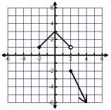
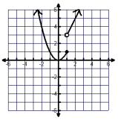
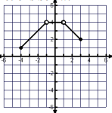

Directions: Carefully graph each of the following. Identify whether or not the graph is a function. Then, evaluate the graph at any specified domain value. You may use your calculators to help you graph, but you must sketch it carefully on the coordinate plane!
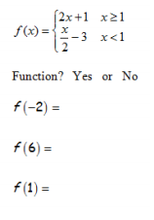
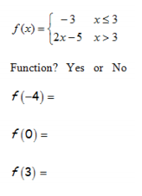
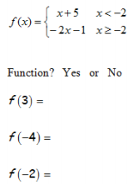

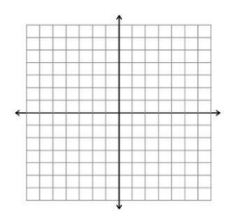

Directions: Graph the inverse of the following graphs on the same coordinate plane.
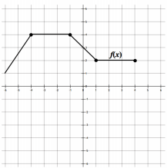
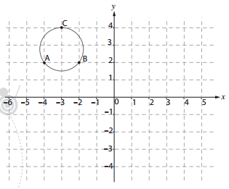
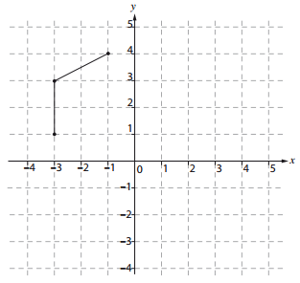

Directions: Find the inverse of the following functions. Is the function 1-1?

- f(x) = 2x – 3
- f(x) $=\frac{x-5}{x}$
- f(x) = 5x² – 4

