Station 1:
Radical Operations

Simplify the following radical equations.

- $21\sqrt{27x^{5}}$
- $3\sqrt{98a^{3}b^{7}}$

- $\sqrt{12}∙\sqrt{-75}$
- $\left(6+5i\right)(2-i)$

- Solve for x and y: $\left(x+yi\right)-\left(2-i\right)=12+7i$

Rationalize each denominator and simplify each expression.

- $\frac{5}{10-3i}$
- $\frac{3}{7+\sqrt{2}}$

Station 2:
Factoring

Factor each of the following. Check your work by FOILing or BOXing your work.

- 12x² – 27

- 2x² + 7x + 5

- 8x³ – 27

- x² – 10x + 9

- 25x⁴z + 15x³z + 5x²z

- 2y – 8 + xy – 4x

Station 3:
Solving Quadratics

Solve each equation by using the Quadratic Formula.
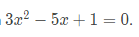

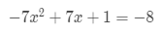

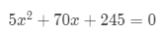

Solve each equation by factoring.
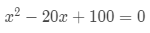

- 8x² + 7x – 1 = 0

Station 4:
Absolute Value Equations

Solve each of the following. Check your work for extraneous solutions.

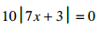

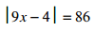

Station 5:
Absolute Value Inequalities

Solve each of the following. Graph your solutions of the number line provided and write your answers in both interval and set builder notation.

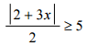
- 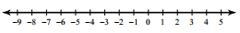

- 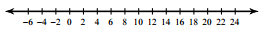

- 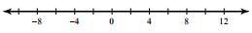

- -2|3x + 5| < 10

