TRIGONOMETRY RELAYS – SET ONE
1. The highest average temperature for Winston-Salem is 105*F, and occurs on August 2. The coldest average temperature is 14*F and occurs on February 8. Write a cosine equation for this information.

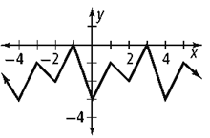
2. Find the period, midline and amplitude of

3. $(3+\sqrt{11)}(6-2\sqrt{11})$

4. Sketch the angle -145$°$

ANSWERS:
1. 2.

3. 4.

RELAYS – SET TWO
1. Find the exact value of the sine and cosine of -225$°$

2. Convert the following to degrees: -5π radians

3. How much time passes as the minute hand of a clock hits $\frac{π}{4}$?

4. Find the exact value of sine and cosine of $-\frac{5π}{6}$ ?

ANSWERS:
1. 2.

3. 4.

RELAYS – SET THREE
1. Sketch the angle of 576$°$

2. Use the graph below to find the period and amplitude
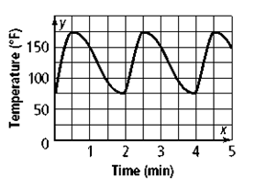

3. A Ferris wheel has a radius of 25m and starts 2m above the ground. It rotates once every 45 seconds. Determine the cosine equation of the graph, if the rider gets on at the lowest point.

4. Convert the given degrees to radians: $578°$

ANSWERS:
1. 2.

3. 4.

