Example 2:  $$f\left(x\right)=x^{2}-6$$ |  |  | Example 1:  $$f\left(x\right)=\left|x-1\right|$$
Example 4:  $$f\left(x\right)=({x+1)}^{2}+3$$ | Glue this side down! |  | Example 3:  $$f\left(x\right)=-\sqrt{x+4}$$
Example 6:  $$f\left(x\right)=-\frac{1}{5}x^{3}+5$$ |  |  | Example 5:  $$f\left(x\right)=3{(2)}^{x+2}-5$$
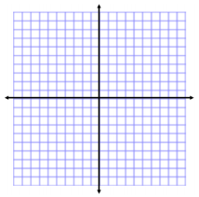  Parent Function: ___________________  Transformations:  x -2 -1 0 1 2  Old 2 1 0 1 2  New |  | Parent Function: ___________________  Transformations:  x -2 -1 0 1 2  Old 4 1 0 1 4
Parent Function: ___________________  Transformations:  x  y |  | Parent Function: ___________________  Transformations:  x  y
Parent Function: ___________________  Transformations:  x  y |  | Parent Function: ___________________  Transformations:  x  y

