STATION #1:
Normal Distribution

1. | 2.
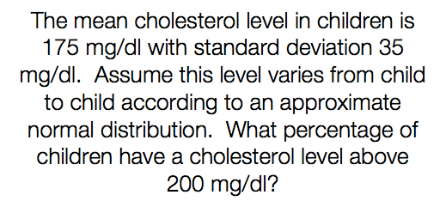 | 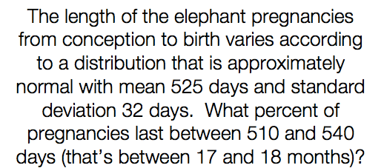
3. | 4.
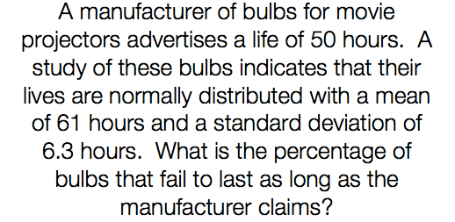 | 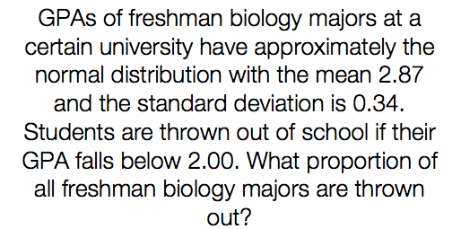

STATION #2:
Measures of Central Tendency
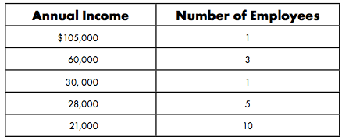

- Find the mean, median, mode, and range.

- In negotiations, the owner of the company will probably use the ___________ to describe the company. Why?

- The union leader (person negotiating for the workers) will probably use the _____________ to describe the company. Why?

- A statistician would probably use the _____________ to describe the company. Why?

STATION #3:
Interpreting Data
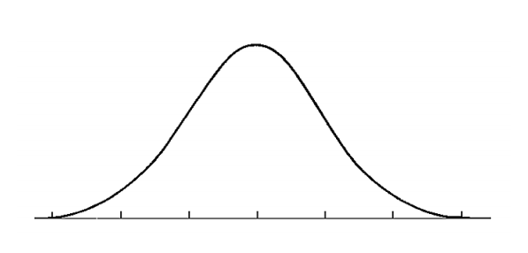
- 2000 sophomores at UNC Charlotte took a physics test. The scores were distributed normally with a mean of 78 and standard deviation of 5. Label the following curve and answer corresponding questions.

- What percentage of scores are between 73 and 83? _____________
- What percentage of scores are less than 68? _____________
- What percentage of scores are between 70 and 77? _____________
- What percentage of scores are greater than 82? _____________
- Approximately how many physics students scored between 78 and 84?
_____________
- Approximately how many physics students scored less than 67?
_____________

STATION #4:
Z-Scores
- On a Statistics test, the class mean was 63 and the standard deviation was 7. Calculate the z-score if you got a 72 on the test.

- For the Biology test, the mean was 68 and the standard deviation was 10. Calculate the z-score if you got a 72 on the test.

- For the English test, the mean was 76 and the standard deviation was 8.5. Calculate the z-score if you got a 72 on the test.

- Compare the results between the 3 tests in Question 1.

- Describe in words what a z-score actually means.

- The scores on a recent test are normally distributed. John’s test score of 65 was 1 standard deviation below the mean. Kristin’s test score of 89 was 2 standard deviations above the mean. What are the mean and standard deviation for the test score distribution?

STATION #5:
Margin of Error & Confidence Interval

- The students in Ms. Smith’s class have obtained the following scores on the state test:

71 70 69 76 68 73 76 72 68 76 68 70
What is the 95% confidence interval for the data?

- In a survey of 2500 high school students, 1952 said they had to purchase some of their own clothes from their allowance. What is the margin of error?

- In a survey of U.S. citizens aged 65 and over, an average of 52% said that they participated in activities at their local Senior Citizen Center at least twice a year. The margin of error was 5%. What does the 5% indicate about the results?

- In an international survey with 4,561 respondents, 46% said that 'coaching or mentoring' has a great impact on career success. Find the margin of error of the survey and the 95% confidence interval.

STATION #6:
Sampling and Randomization

- A politician wants to know what issues are most important to the voters in his district. Identify the sampling method and state any bias in the method.

Convenience Sample | Volunteer Sample | Systematic Sample

  - The politician spends 9:00 am to 4:00 pm on Tuesday talking to people as they enter a grocery store.

  - The politician sets up a questionnaire on his website.

  - The politician uses the phone book and selects every 50th citizen to call.

- State whether each method would produce a random sample. Explain your reasoning.

  - Surveying people coming out of a movie theater to find out people’s favorite entertainment.

  - Placing a survey in the local newspaper to determine how people voted in the last election.

  - Selecting students at a school to answer questions by randomly drawing their student identification numbers from a hat.

