AFM Solving Trig Equations Unit 1

*SWBAT solve equations involving trigonometry by using their calculator.*

**Example 1:** Solve the equation in the interval from 0 to 2π.

* Y1 = Left side of equation, Y2 = right side of equation
* Find the intersections (solution is the x-value)

1. 
2. 
3. 
4. 

**In-Class Practice:** Solve for x. Show all work.

1. 
2. 
3. 
4. 
5. 
6. 
7. 
8. 

Part 2: Graphing Trig Functions Review

***Directions:*** *Show all work and tables on a separate page. Only graph your functions on this page.*

1. Graph the sine function is the amplitude is 2 and the period is $\frac{2π}{3}$.
2. Graph

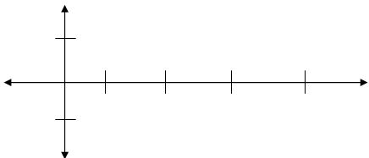

1. Graph $y=3cos{\frac{θ}{2}}$
2. Graph

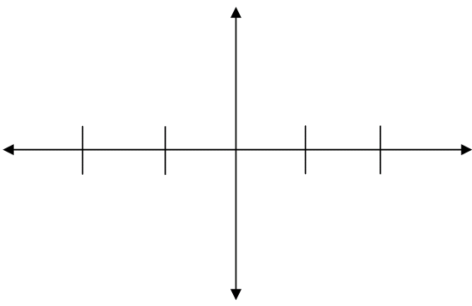

1. Graph $y=2csc{πθ}$
2. Graph

