Round 1 Solutions: 3, 0, 2, -1 Sum = 4

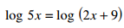 | 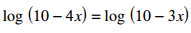
 | 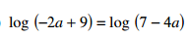

Round 2 Solutions: 12.5, 20, 5, 7 Sum = 44.5

49

49

49
49

49

49

Round 3 Solutions: -0.5, -2, -100, 84 Sum = -18.5

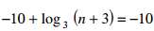

Round 4 Solutions: -1 and 1, 6, 1/28, 2 and -2 Sum = 169/28

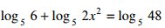
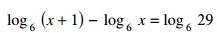

Round 5 Solutions: -6, -7 and -4, 8 and -2, -2 and -7 Sum = -20

