 | S | ine
 | O | pposite
GLUE | H | ypotenuse
THIS | C | osine
SIDE | A | djacent
DOWN | H | ypotenuse
 | T | angent
 | O | pposite
 | A | djacent

$$Sin ∠A= \frac{ }{ }$$
The leg OPPOSITE of $∠A$ is ______. | 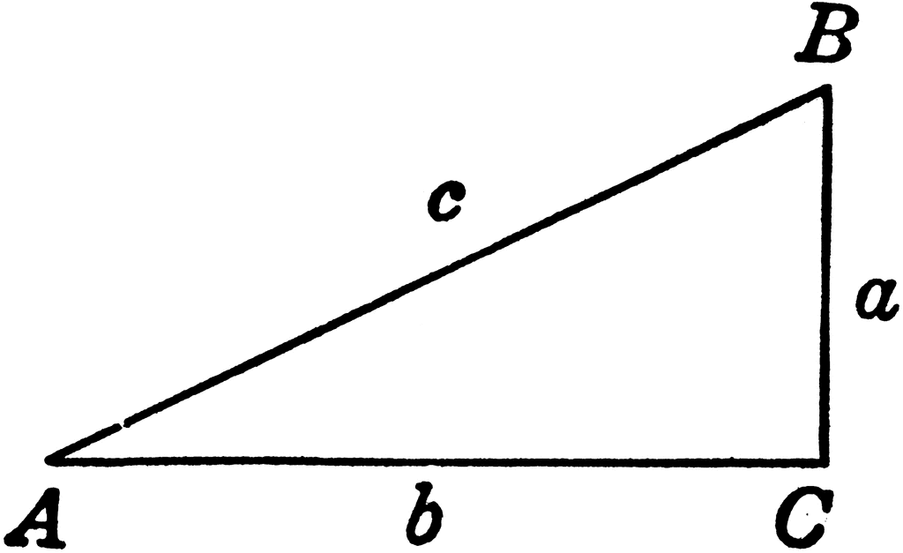
The HYPOTENUSE is ______.
$$Cos ∠A= \frac{ }{ }$$
The leg ADJACENT of $∠A$ is ______.
The HYPOTENUSE is ______.
$$Tan ∠A= \frac{ }{ }$$
The leg OPPOSITE of $∠A$ is ______.
The leg ADJACENT of $∠A$ is ______.

