Name: _________________________
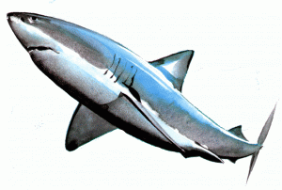

Application of Distance and Midpoint
Part A: The Midpoint Formula
- Plot and label the following points on the grid provided.
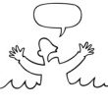
- Stranded man (-3, 2) d. Empty boat (0, -4)
- Life jacket (-2, -4) e. Hungry shark (2, -2)
- USS Coast Guard boat (4, 5) f. Oil Rig (3, 0)
- What is the midpoint between the oil rig and the life jacket?

- A Styrofoam cup from a careless boater is floating midway between the stranded man and the empty boat. What is the point of this location?

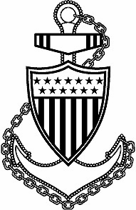
- The Coast Guard boat is midway between the stranded man and the Coast Guard Headquarters. What are the coordinates of the coast guard headquarters? (Hint: Headquarters may not fit on the grid).
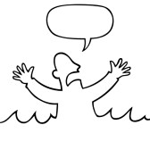
HELP!

(4, 5)
(-3, 2)
(?,?)

Part B: The Distance Formula

- Use the distance formula to find the distance between the stranded man and all of the other points. Show all work. One inch equals 15 miles. Fill in the table completely.
Object | Work Using Distance Formula | Simplified Radical | Rounded Distance | Converted mileage  1 in. = 15 miles
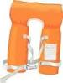
Life Jacket

USS Coast Guard boat
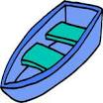
Empty boat
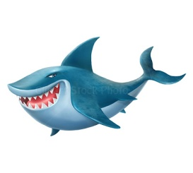
Hungry shark
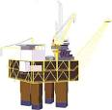
Oil Rig

- If the hungry shark is traveling towards the stranded man at 25 miles per hour, and the Coast Guard is traveling towards him at 30 miles per hour. Who will reach the stranded man first?

Time for shark:______________ Time for Coast Guard:_____________ Who wins?!_______________

