Point | Line | Plane | Line Segment
Ray | Angle | Obtuse Angles | Acute Angles
Right Angle | Straight Angle | Supplementary Angles | Complementary Angles
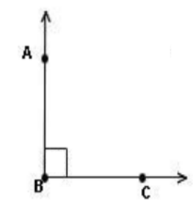 | 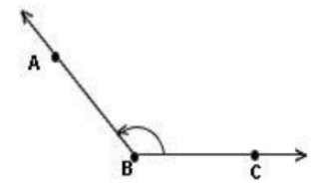 | 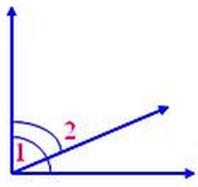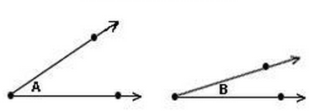 | 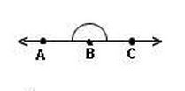
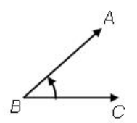 | 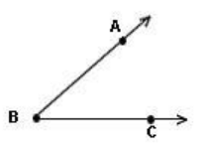 | 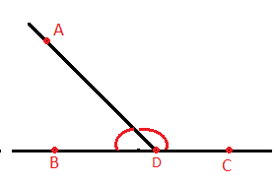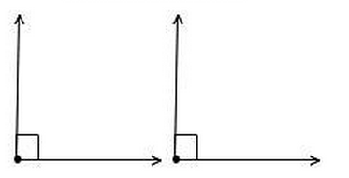 | 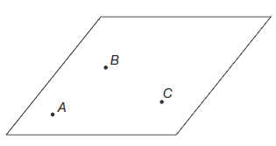

An angle whose measure is less than 90 degrees. | An angle whose measure exactly 90 degrees. | An angle whose measure is greater than 90 degrees but less than 180 degrees.
An angle whose measure is exactly 180 degrees. | Two angles whose measurement sum equals 90 degrees. | Two angle whose measurement sum equals 180 degrees.
A straight path that extends in two opposite directions without end and has no thickness. | Part of a line that consists of two endpoints and all the points in between. | Part of a line that consists of one endpoint and all the points of the line on one side of the endpoint.
A flat surface that extends without end, has no thickness, and contains infinitely many lines. | - undefined  - a location  - no size | Formed by two rays with the same endpoint.

