1. Simplify
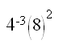

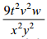
Answer:

9. What is the value of:

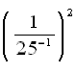

Answer: 1
8. Simplify:
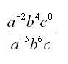

Answer: 625
2. Simplify:
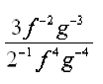

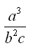

Answer: ___
10. Simplify:
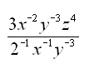

Answer: 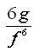
6. Simplify:
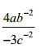

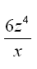

Answer:

3. Simplify:
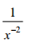

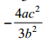
Answer:

7. Simplify:
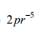

Answer:

5. Simplify:
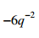

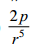
Answer:

4. Simplify:
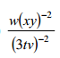

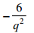
Answer:

