1. Which expression is equivalent to (3x5 + 17x3 – 1) + (-2x5 – 6) ?
2. X5 + 17x3 – 7 C. 5x5 + 17x3 + 7
3. X5 – 11x3 – 1 D. -6x5 + 17x3 + 6
4. The sum of two numbers is 24. The sum ofthe squares of the two numbers is 306. What is the product of the two numbers?
5. 119 C. 135
6. 128 D. 144
7. Which equation has exactly one solution?
8. 4x2 – 12x - 9 = 0 C. 4x2 – 6x – 9 = 0
9. 4x2 + 12x + 9 = 0 D. 4x2 + 6x + 9 = 0
10. A circular pond is modeled by the equation x2+y2= 225. A bridge over the pond is modeled by a segment of the equation x– 7y=–75. What are the coordinates of the points where the bridge meets the edge of the pond?
11. (9, 12) and (–12, 9) C. (9, –12) and (–12,–9)
12. (9, 12) and (12, 9) D (–9, 12) and (12,–9)
13. If *t*is an unknown constant, which binomial must be a factor of 7m2 + 14m – *t*m – 2*t*?
14. 7m + *t* C. m + 2
15. m – *t* D.m - 2
16. Which expression is equivalent to ?
17.  C. 
18.  D. 
19. Which graph displays the function f(x)=(2x+ 3)(x– 2)?
20. 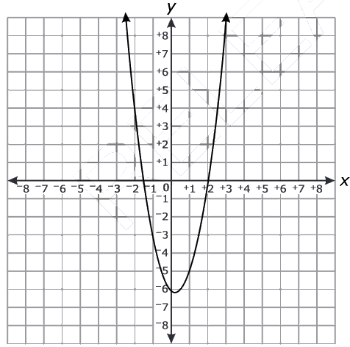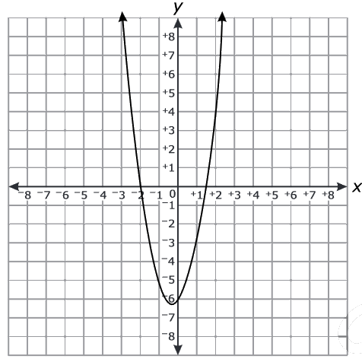 C.
21. 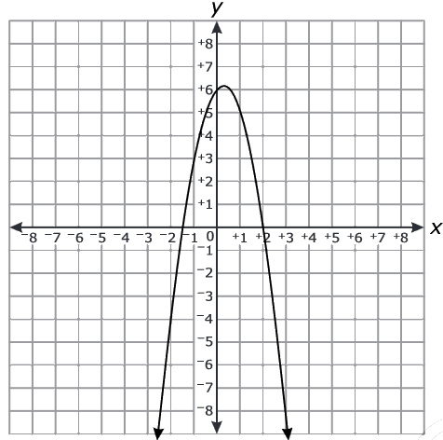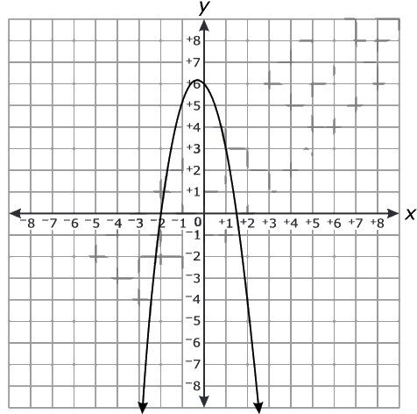 D.
22. Find the product: (n2+ 6n− 4)(2n− 4)
23. Simplify the rational expression: 
24. Solve the quadratic equation by using the quadratic formula: 10n2– 9= 5n
25. What is the image when reduced by $\frac{1}{2}$.

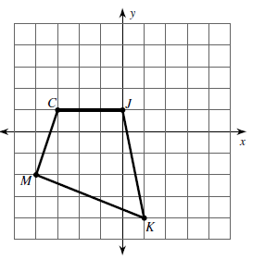

1. What is the rule that maps the preimage to the image?

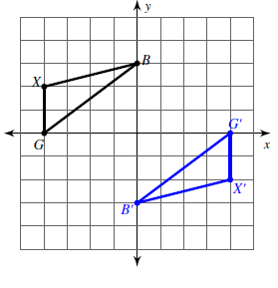

1. Translate the image up 4 and right 2.

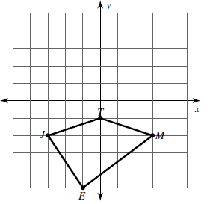

1. Translate the figure ABCD (x, y)→(x+2, y-1) and then reflect it across y=2. Where A(-5, -2), B(-4,1), C(0, -1), D(-2, -4).

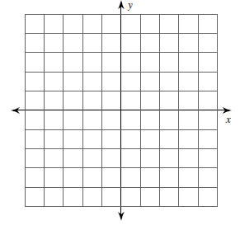

1. State whether the two triangles are congruent and how?

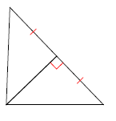

1. Solve for x and then find all the angle measurements.

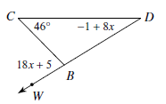

1. Use the word bank to fill in the reasons and statements in the correct order to prove the following proof.

Given: *R* is the midpoint of . 

**Word Bank**

* 
* Reflexive Property of Equality
* *R* is the midpoint of 
* Given
$\overline{SR}≅\overline{RU}$

* Definition of Midpoint
* 
$\overline{VR}≅\overline{VR}$

* SSS

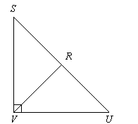 Prove: 

1. Fill in the blanks in the given proof.

Given: A trapezoid. . .  perpendicular to  and .  perpendicular to  and .

Prove: 

**Statements Reasons**

1)_________________________________

2)_________________________________

3)_________________________________

4)_________________________________

1) Given

2) Definitions of Perpendicular angles

3) Definition of right triangles

4)_________________________________

1. **Given:** ∠*E* ≅∠*H;* ∠*HFG* ≅∠*EGF*

**Prove:** Δ*EGF* ≅Δ*HFG*

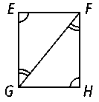

1. Given: 

Prove: 



1. The angel of elevation from point G on the ground to the top of a flagpole is 20˚. the height of a flagpole is 60 feet. Which equation could find the distance from point G to the base of the flagpole?

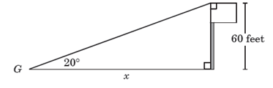

A. $\sin{20}=\frac{x}{60}$ B. $\sin{20}=\frac{60}{x}$

C. $\tan{20}=\frac{60}{x}$ D. $\tan{20}=\frac{x}{60}$

1. A mountain climber stands on level ground 300m from the base of a cliff. The angle of elevation to the top of the cliff is 58˚. What is the height of the cliff?
2. A 20 foot ladder is leaning against a wall. The foot of the ladder is 7 feet from the base of the wall. What is the measure of the angle the ladder forms with eh ground? Round to the nearest hundredth?
3. What is the ratio of the surface areas of two spheres with volumes of 64 cm2 and 125 cm2?
4. What is the approximate area of the trapezoid?

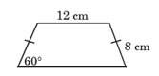

A. 83 cm2 B. 110 cm2

C. 128 cm2 D. 192 cm2

1. Susan is making a small cone out of paper. The cone has a radius of 13.2 cm, and the angle between the lateral surface and the base is 38.6˚. The formula for the alteral area, s, of a cone is $s=πrl$, where r is the radius and $l$ is the slant height. What is lateral area of the cone. Round the the nearest whole number.
2. A dead tree was struck by lightening carusing it to fall over at a point 10 ft up from its base. If the fallen treetop froms a 40˚ angle with the ground, about how tall was the tree originally?

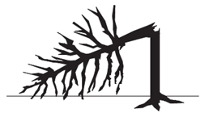

A. 13 ft B. 16 ft

C. 23 ft D. 26 ft

1. A sign is shaped like an equailateral traingle. If one side of the sign is 40 inches what is the area of the sign?
2. An inflated round ballon with radius r=50 centimeters holds 523,600 cubic centimeters of air. When the balloon is contracted such that the radius is $\frac{2}{3}$ the original size, what is the volume of the partially deflated balloon?

A. 1.94 X 104 cm2 B. 1.55 X 105 cm2

C. 1.75 X 105 cm2 D. 3.49 X 105 cm2

1. A cylinder with a height of 6 inches and a radius of 3 inches is inside a rectangular prism, as shown below.

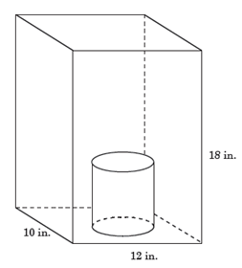

A point inside the rectangular prism will be chosen randomly. What is the probability that the point will also be inside the cylinder?

1. A cube is painted as shown. The three faces that are not seen are not painted.

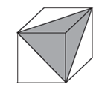

If a point on the surface of the cube is randomly chosen, what is the probability that it will lie in the painted area?

1. A circle is inscribed in a square, as shown below.

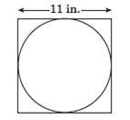

If a point is randomly chosen inside the square, what is the chance that the point lies outside the circle? Round answer to nearest whole percent.

1. To win a carnival game, Keisha must throw a dart and hit one of the 25 circles in a dart board that is 4 feet by 3 feet.

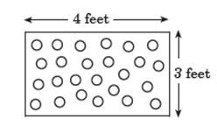

What is the probability that a randomly thrown dart that hits the dart board will hit a circle?

1. A spherical paintball measures 1.5 centimeters is diameter. How much paint can the paintball hold?

When standing upright, Gary knows his eyes are 6 feet above ground level. To determine the depth of a well, he stands in the position shown.

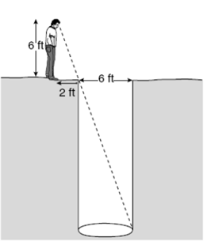

How deep is the well?

1. Determine the length of the side of a square in simplest radical form if the diagonal of the square is 7 cm.
2. Determine the length of the rectangular prism using the given information.

9in

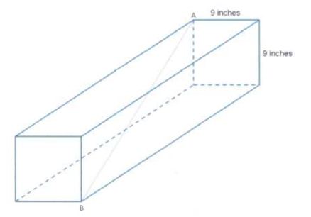

9in

1. Find the trigonometric ratios of angle I.

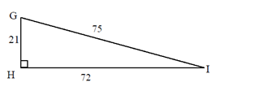

1. The ratio of a pair of corresponding sides in two similar triangles is 5:3. The area of the smaller triangle is 108 cm2. That is the area of the larger triangle?
2. Find the area of the figure.

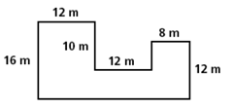

1. Solve each problem.

