Graphing Exponential Functions
Horizontal Asymptote = k-value

Example 1: Graph $y= 2^{x+3}-5$
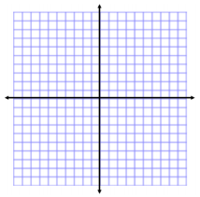

Transformations: Asymptote:

Domain: Range:

Example 2: Graph $y= -3^{x-1}+6$

Transformations: Asymptote:

Domain: Range:

Glue this side down!

Graphing Exponential and Logarithmic Functions

Exponential Function: A function whose unknown (x) is located in the exponent.

EX: y = 2^{x}

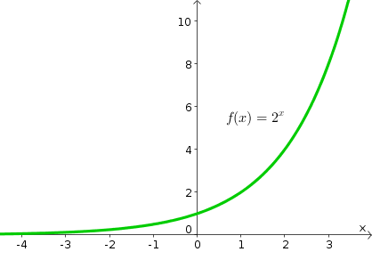

Logarithmic Function: The inverse function of an exponential function.

EX: y = log₂x

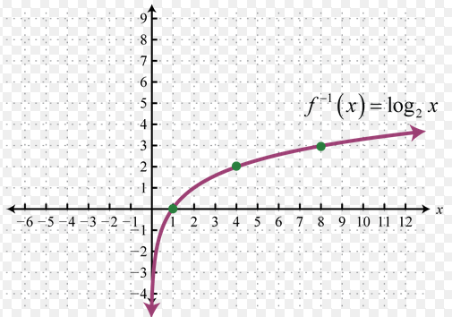

Finding the Inverse of a Logarithm

Step 1: Swap x and y
Step 2: Isolate the log
Step 3: SWOOSH to convert into an exponential function and solve for y

Graphing Logarithmic Functions

Step 1: Find the inverse of x and y
Step 2: Make a table
Step 3: Swap the x and y values on the table
Step 4: Graph the function (Don’t forget the asymptote!)

Vertical Asymptotes = h-value

Example 1: Graph y = log₂x + 3

Domain: Range: Vertical Asymptote: Transformations:

Example 1: Find the inverse of y = log₅x

Example 2: Find the inverse of y = log₇x - 1

Example 3: Find the inverse of y = log₃(x-2)

Example 2: Graph y = log₄(x – 2) + 1

Domain: Range: Vertical Asymptote: Transformations:

Example 4: Find the inverse of y = log₄(x + 3) - 8

