How to Use a Protractor
Cut out and sort the “using a protractor steps onto the foldable. The title steps go on the front and match the instructions and images on the inside.

Look at the angle. If it is smaller than a right angle it is acute; if it is larger than a right angle it is obtuse. |  | 3. Rotate the zero-edge
Rotate the zero-edge of the protractor to line up with one side of the angle and for the other side of the angle to cross the protractor’s scale. |  | 2. Position the center mark
Place the center mark of the protractor on the vertex of the angle. |  | - Obtuse or Acute?
Read the size of the angle.  Acute Angle = numbers smaller than 90  Obtuse Angle = numbers larger than 90 |  | 4. Read the size of the angle
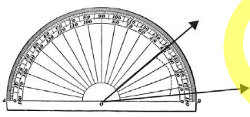 |  | 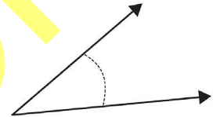
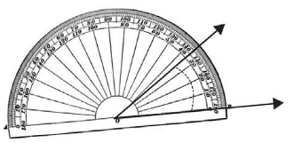 |  | 