Circles Quiz Review Name: _________________________

Math 3 Date: ____________

**Directions:** Answer each of the following.

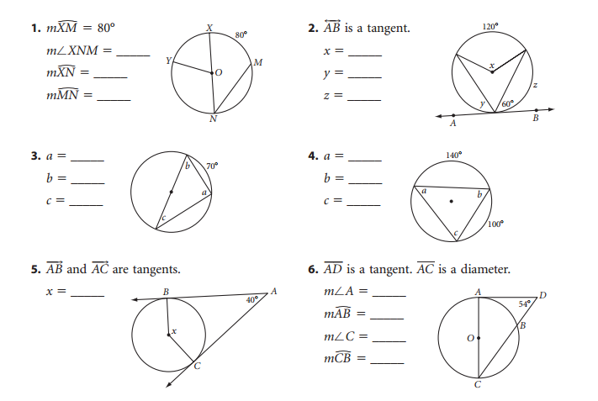

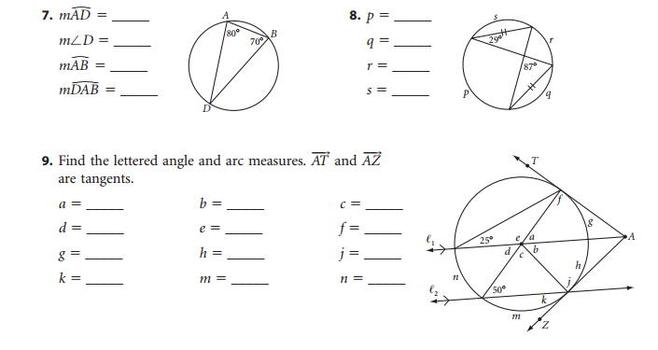

Mixed Review:

