|  |
| --- |
| Homework 1.4 |

Geometry Applications B

Find the value of the given variables and determine the measure of the angles.

|  |  |  |  |
| --- | --- | --- | --- |
| 1. |  | 2. |  |

|  |  |  |  |
| --- | --- | --- | --- |
| 3. |  | 4. |  |

|  |  |  |  |
| --- | --- | --- | --- |
| 5. |  | 6. |  |

|  |  |  |  |
| --- | --- | --- | --- |
| 7. |  | 8. |  |

|  |  |  |  |
| --- | --- | --- | --- |
| 9. | Two angles form a linear pair. If the larger is 10 more than 5 times the smaller angle, find the measures of each angle. | 10. | A ball is rolled into a wall and it bounces of so that the angle it hits the wall is equal the angle it bounces off (). Find the. |

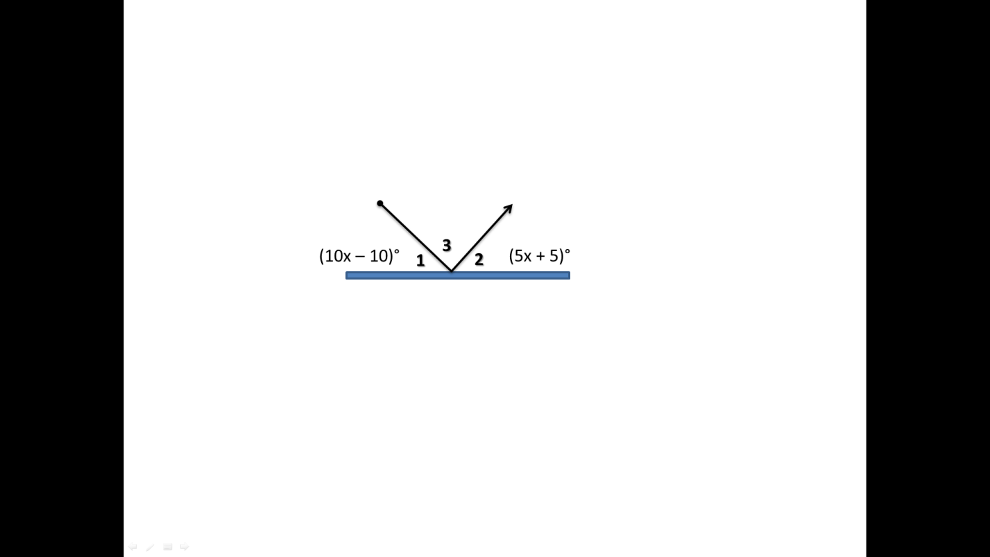

**Review Equations**

11. Solve and write answer in set notation. 12. Solve graph and final answer in interval notation.

 