Homework 9.2: Normal Distribution Name: __________________________
Math 3

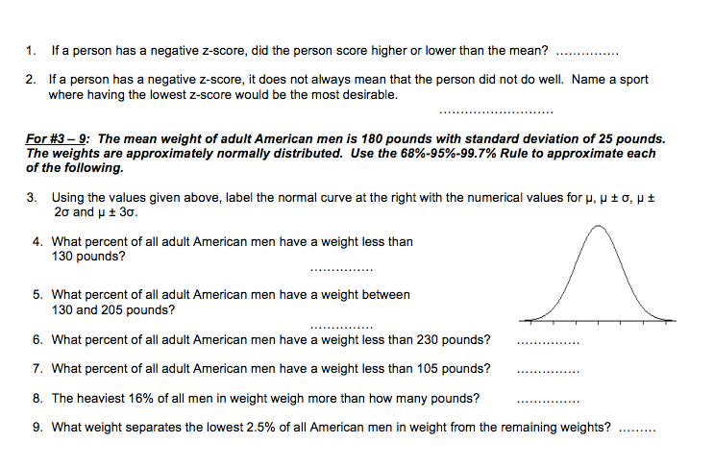
- A set of 1000 values has a normal distribution. The mean of the data is 120, and the standard deviation is 20. Draw and label a normal curve that represents this data.

  - What percent of the data is in the range 80 to 100?

  - What percent of the data is in the range 60 to 140?

  - How many values are within the limits 100 and 160?

  - How many values are greater than 140?

  - How many values are within one standard deviation from the mean?

Homework 9.3: Z-Scores Name: __________________________
Math 3

- Find the z-scores of the following data if the mean is 68 and the standard deviation is 3.

  - Raw Score: 88
  - Raw Score: 63

- Find the standard deviation if the mean of a sample is 72, a z-score of 3, and:

- Raw Score: 44
- Raw Score: 79

- A group of students weighs 500 US pennies. They find that the pennies have normally distributed weights with a mean of 3.1g and a standard deviation of 0.14g

  - What percentage of pennies will weigh between 2.8 and 3.3g?
  - What percentage of pennies will weigh between 2.11 and 3.5g?

  - What percentage of pennies will weigh less than 2.96g?
  - What percentage of pennies will weigh more than 3.4g?

- Suppose the heights of adult men are normally distributed. The heights of a sample of 30 men are shown below in inches.

65, 83, 69, 67, 69, 67, 67, 72, 85, 68, 73, 65, 67, 65, 72, 71, 67, 73, 68, 72, 61, 75, 66, 78, 65, 71, 68, 76, 67, 68

  - Compute the mean and standard deviation of the sample.
  - Draw a normal curve that represents the distribution of adult male height based on the sample.

  - What percent of men have a height above 74”?

  - What percent of men have a height below 60”?

  - What percent of men have a height between 65” and 70”?

