Homework 9.1: Analyzing Data Unit 9
Math 3

Directions: Solve each of the following. Show as much work as needed.

- The heights (in inches) of eight tomato plants are: 36, 45, 52, 40, 38, 41, 50, and 48
- Find the range, mean, median, and mode(s) of the tomato plant heights.

- You and your friend have a friendly competition going on about the scores on your math quizzes. Both of your scores for the first five quizzes are given below.
Your quiz scores: 18, 16, 19, 15, 17
Friend’s quiz scores: 20, 20, 13, 12, 17

- Find the mean, median, and mode of both sets of data.

- Do you or your friend have the higher mean? Who has the highest median?

- In which dataset is the median value equal to the mean value?

- {2, 4, 6, 7, 8}
- {12, 18, 20, 23, 24}
- {16, 17, 18, 19, 20}
- {50, 60, 65, 75, 85}

- Below are percentages of all doctorates earned by men and women between 1980 and 1989.

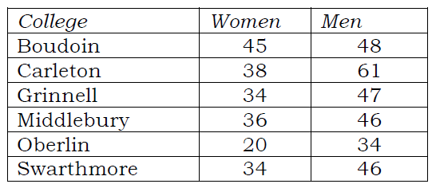

- What is the difference between the means of the percentages of doctorates earned by women and men?

- What is the difference in the ranges of the percentages of doctorates earned by men and women?

- How much higher is the median of the percentage of doctorates earned by men than the median of the percentage earned by women?

Directions: Find the mean, median, mode, and range and standard deviation for each problem. For the standard deviation, solve by hand. Check your answer in the calculator.

- 239, 230, 500, 120, 230

Mean: __________ Median: __________ Mode: __________ Range: _________

Standard Deviation:___________________________________________

- 32, 54, 87, 12, 30, 72, 13, 49, 80, 72

Mean: __________ Median: __________ Mode: __________ Range: _________

Standard Deviation:___________________________________________

- 34.9, 23.5, 83.7, 65.8, 34.9, 20

Mean: __________ Median: __________ Mode: __________ Range: _________

Standard Deviation:___________________________________________

- You scored an 65%, 84%, 75%, and 95% on your last four math tests. If you want to earn an 85% in the class, what score must you get on your next math test?

- You scored a 88%, 76%, 62%, and 89% on your last four science tests. If your next test counts twice, is it possible to average a 85%?

