Homework 8.8: Inscribed Angles Name: __________________________

Math 3

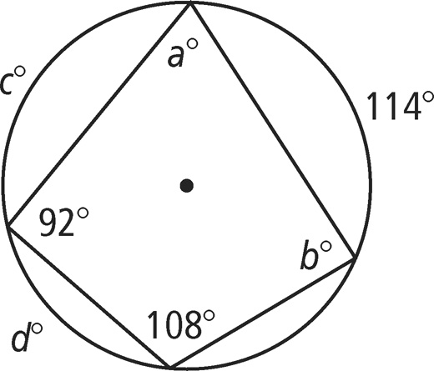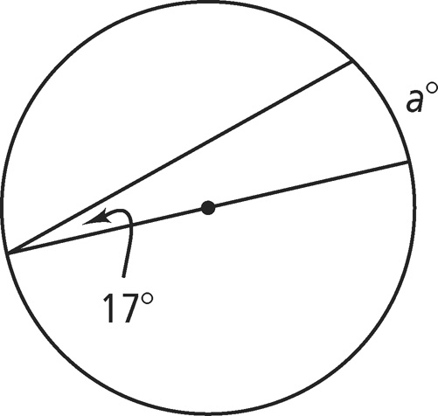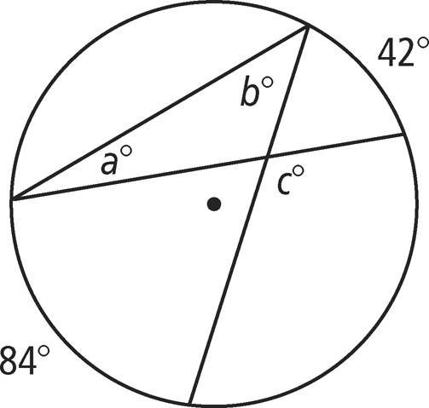**Directions:**  Find the value of each variable. For each circle, the dot represents the center.



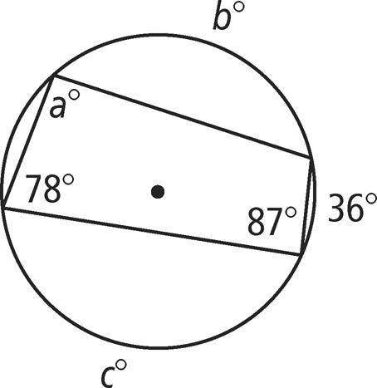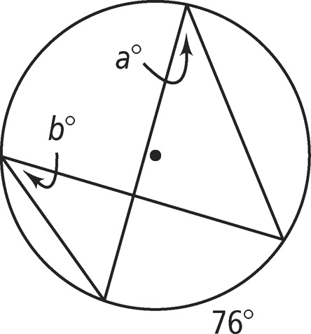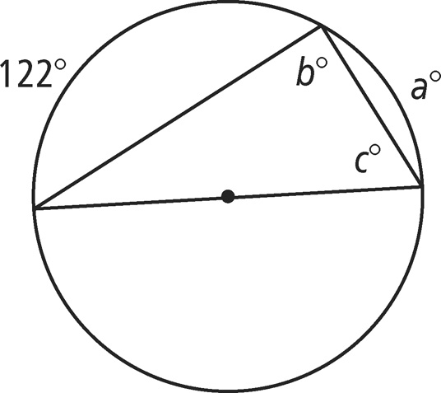



**Directions:** Find the value of each variable. Lines that appear to be tangent are tangent.

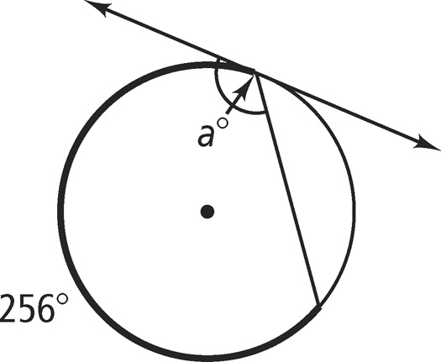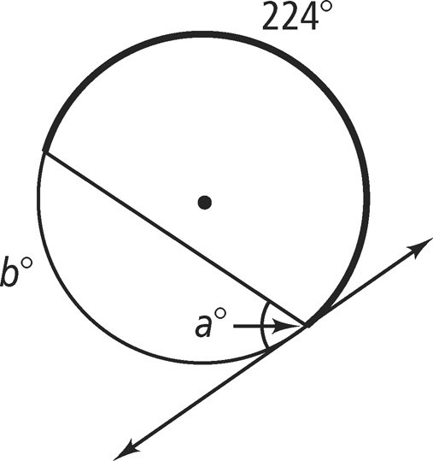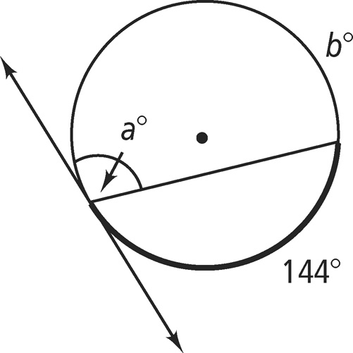



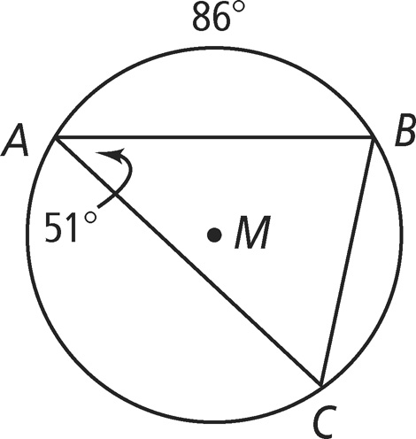**Directions:** Find each indicated measure for *M.*

1. *m*∠*B*
2. *m*∠*C*

1. **
2. 

**Directions:** Find the value of each variable. For each circle, the dot represents the center.

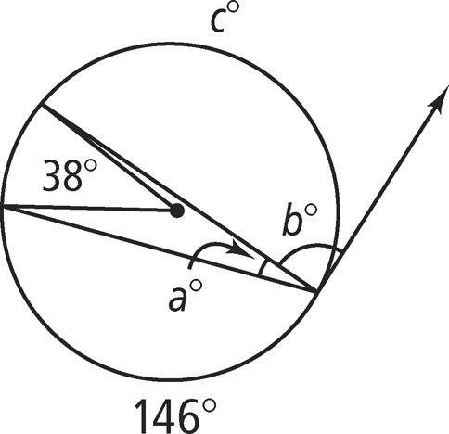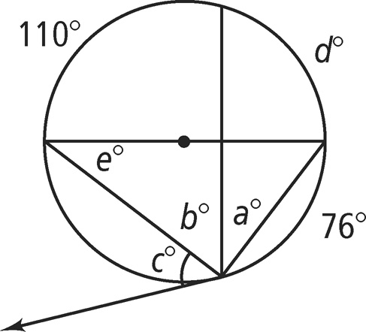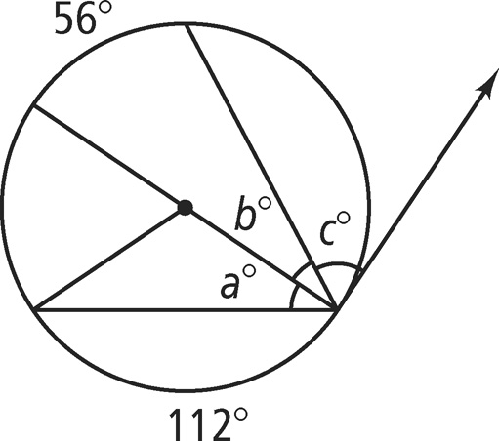



Homework 8.9: Angles and Segments Name: __________________________

Math 3

**Directions:** Solve for x.

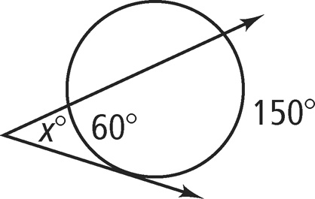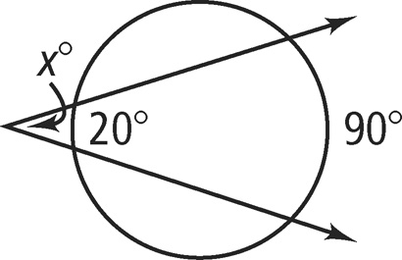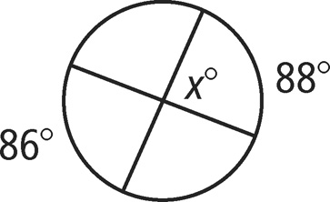



**Directions:** Solve for each variable listed.

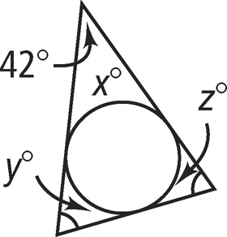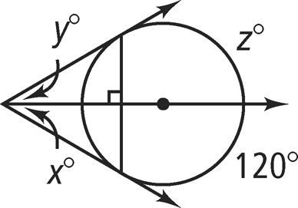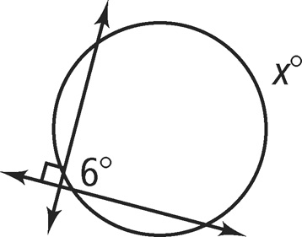



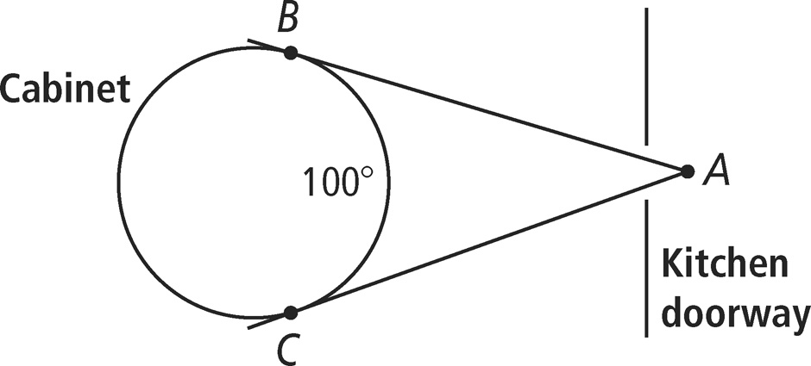

1. There is a circular cabinet in the dining room. Looking in from another room at point *A,* you estimate that you can see an arc of the cabinet of about 100°. What is the measure of ∠*A* formed by the tangents to the cabinet?

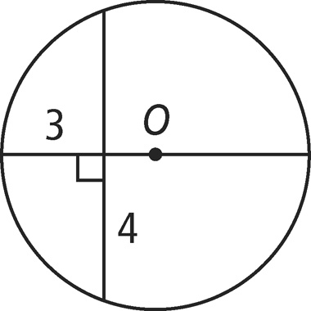**Directions:** Find the diameter of *O.* A line that appears to be tangent is tangent. If your answer is not a whole number, round to the nearest tenth.

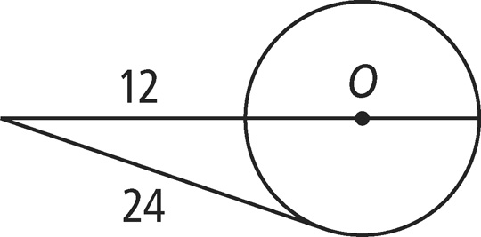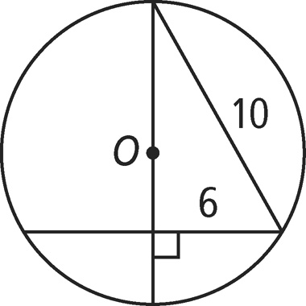



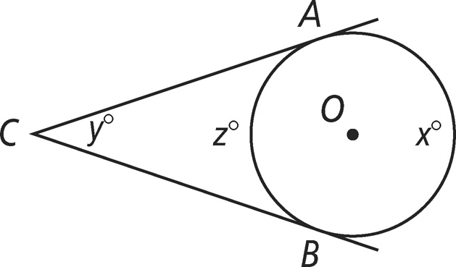**Directions:** ****and are tangents to *O.* Write an expression for each arc or angle in terms of the given variable.

1. using *x*



1. using *y*



1. *m*∠*C* using *x*