Homework 8.6: Tangents of Circles Name: __________________________

Math 3

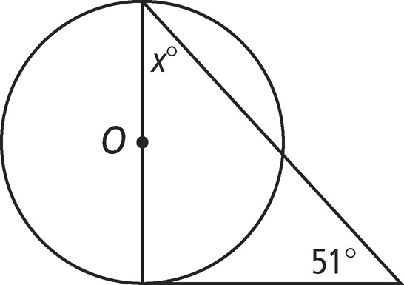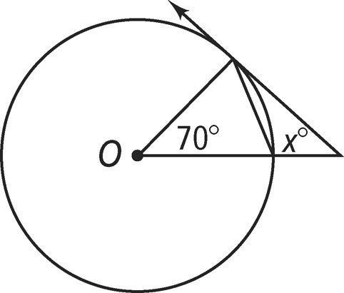**Directions:** Assume that lines that appear to be tangent are tangent. *O* is the center of each circle. What is the value of *x?*

1. 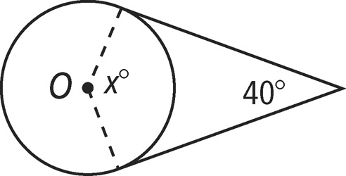

**Directions:** In each circle, what is the value of *x* to the nearest tenth?

1. 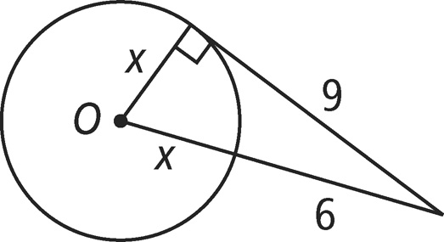
2. 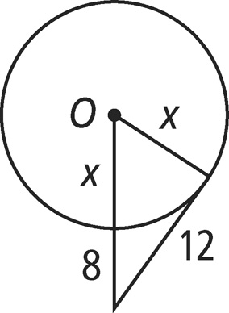
3. 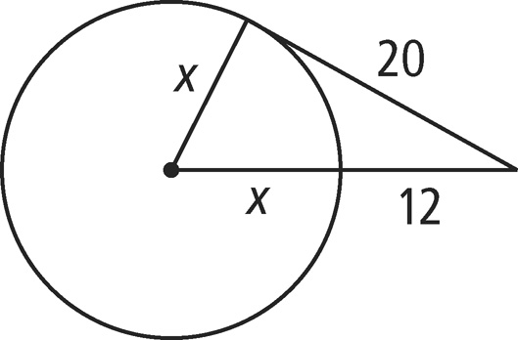
4. and are diameters of *S.* and are tangents of *S.* What is *m*∠*SYZ?*

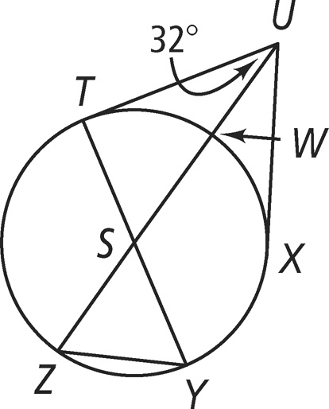

**Directions:** Each polygon circumscribes a circle. What is the perimeter of each polygon?

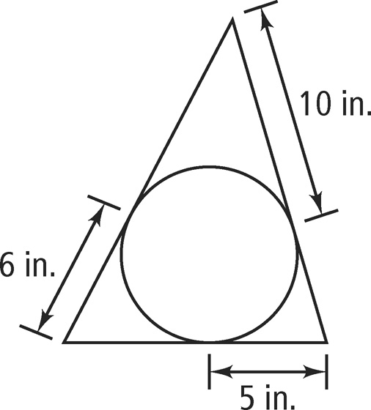

1. 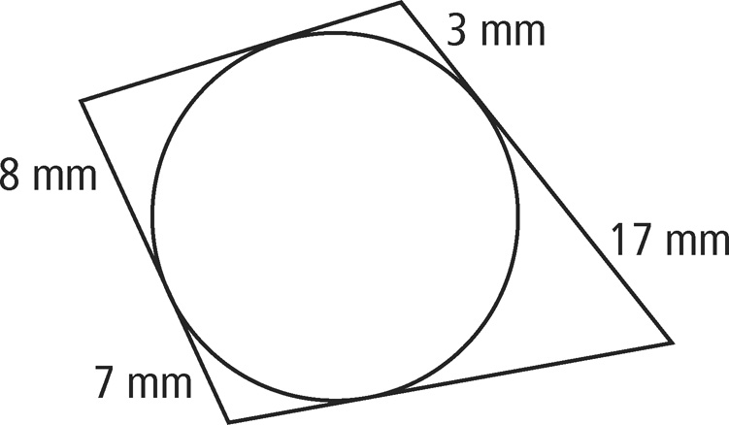

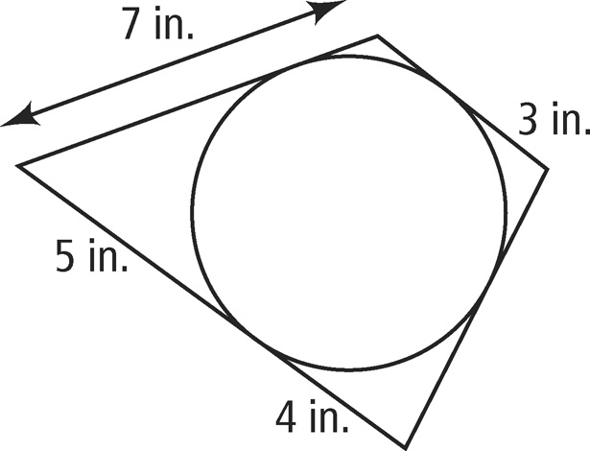

2. 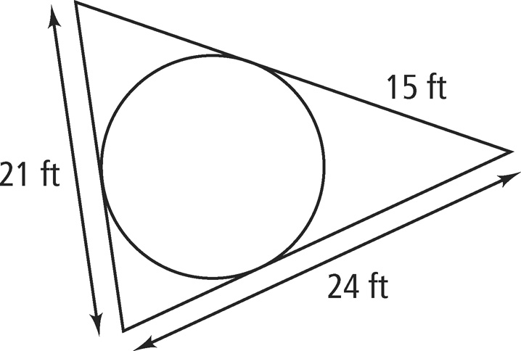

Homework 8.7: Chords & Arcs of Circles Name: __________________________

Math 3

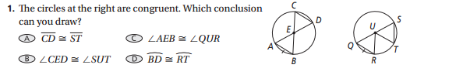

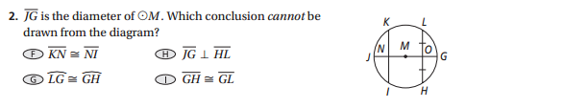

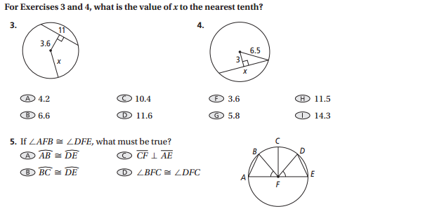

1. A student draws X with a diameter of 12 cm. Inside the circle she inscribes equilateral ∆ABC so that , , and  are all chords of the circle. The diameter of X bisects . The section of the diameter from the center of the circle to where it bisects  is 3 cm. To the nearest whole number, what is the perimeter of the equilateral triangle inscribed in X?