Homework 8.5: Arc Length Name: __________________________
Math 3
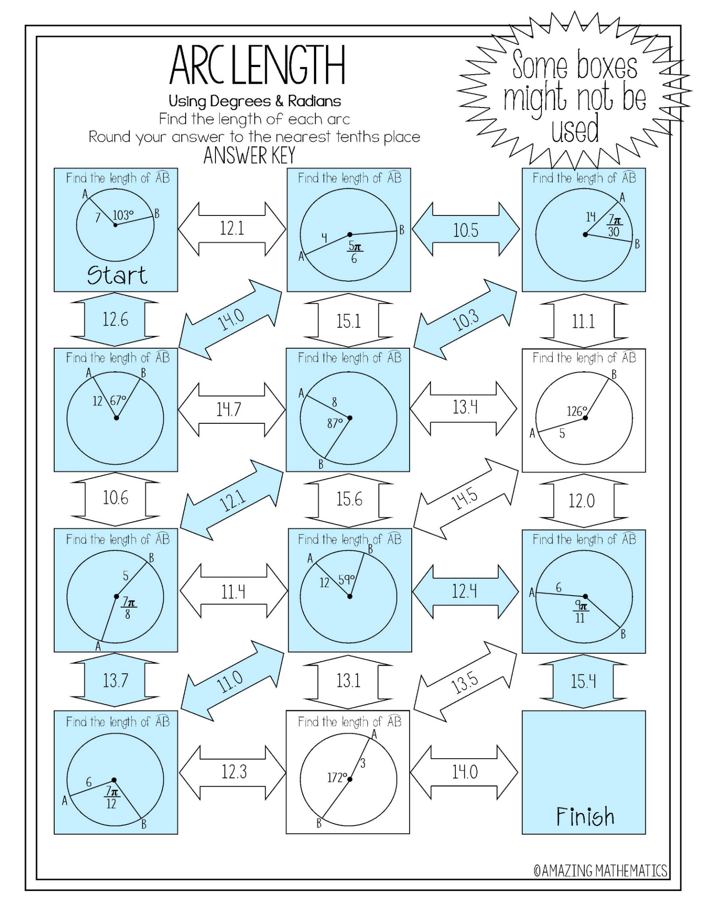
Homework 8.6: Area of a Sector Name: __________________________
Math 3

