Homework 7.9: Applications of Trig Functions Name: __________________________
Math 3

- A water wheel on a paddleboat has a radius of 1 m. The wheel rotates once every 1.46 seconds and the bottom 0.3 m of the wheel is submerged in water. (Consider the water surface to be the x-axis.
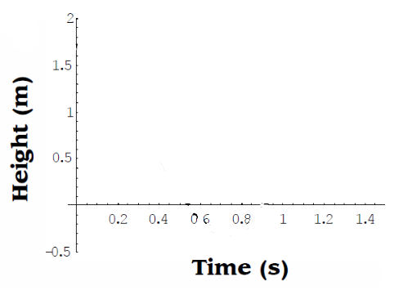
- Determine the cosine equation of the graph, starting from a point at the top of the wheel.

- Graph the height of a point on the wheel relative to the surface of the water, starting from the highest point.

- How long is the point on the wheel underwater?

- The bottom of a windmill is 8m above the ground, and the top is 22m above the ground. The wheel rotates once every five seconds.

- Determine the cosine equation of the graph, starting from a point at the bottom of the windmill.
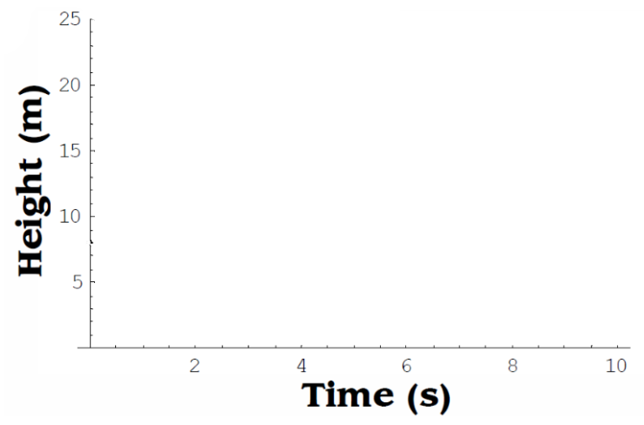

- Draw the graph of two complete cycles.

- What is the height of the point after 4 seconds?

- For how long (over the course of both cycles) is the wheel above 17 m?

- A point on an industrial flywheel experiences a motion described by the formula: $h\left(t\right)=13cos\frac{2π}{0.7}t+15$
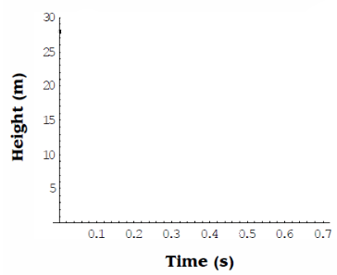

- What is the maximum height of the point?

- At what time is the maximum height reached?

- What is the minimum height of the point?

- At what time is the minimum height reached?

- How long, within one cycle, is the point lower than 6 m above the ground?

- What is the height of the point if the wheel turns for 2 hours and 20 minutes?

