Homework 7.8: Translating Trig Functions Name: _______________________

Math 3

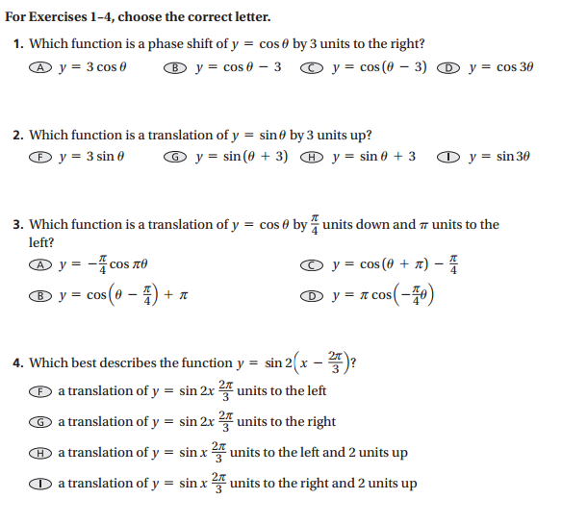



**Describe any phase shift and vertical shift in the graph.**

**6.** *y =* 3 cos *x +* 2 **7.** *y =* 2 cos (*x* − 1) + 3 **8.** 

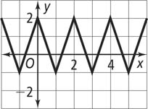**Graph each translation of the graphs below.  
9.** *f*(*x*) − 2 **10.** *f*(*x +* 3)

**Write an equation for each translation.**

**11.** *y =* sin *x*, 2 units down **12.** *y =* cos *x*, *π* units to the left

**13.** *y =* cos *x*, units up **14.** *y =* sin *x*, 3.2 units to the right

**15.** *y =* sin *x*; 3 units to the left, 1 unit down **16.**  *y =* cos *x*; units to the right, 2 units up

**Graph each function.**

**17.** 

**18.** 



**19.** Write one sine and one cosine equation given the following graph.

