Homework 7.7: Sine & Cosine Functions Name: ___________________________

Math 3

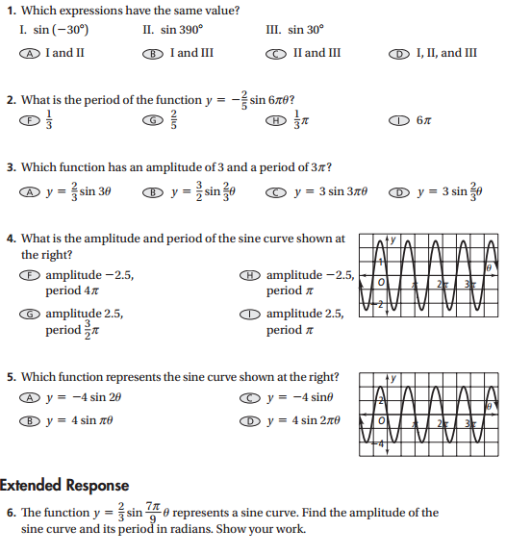

**7.** **Reasoning** The graph at the right shows the sine functions *f*(*θ*), *g*(*θ*), and *h*(*θ*). For each function, *a* > 0.

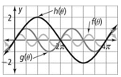**a.** Order the functions by increasing value of *a*.

**b.** Order the functions by increasing value of *b*.

**8.** The function representing the sound wave for the note E above high C has a period of and an amplitude of 0.001. Write a cosine equation for the sound wave.

**Find the period and amplitude of each cosine function. Then, write the equation of the function using the form y=acosbθ.**

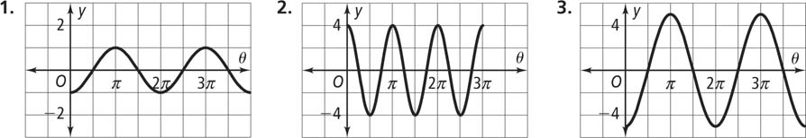**9. 10. 11.**

**Graph each of the following. State the amplitude, period, and the b-value.**

**12.** *y* = −5 cos *θ*

**13.** *y* = −5 sin $\frac{}{10}$*θ*

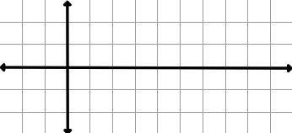

**14.** Write a sine function with an amplitude of 2*π*, a period of 1, and *a* < 0. Then, graph the function.

