Homework 7.6: Exploring Periodic Data Name: ___________________________

Math 3

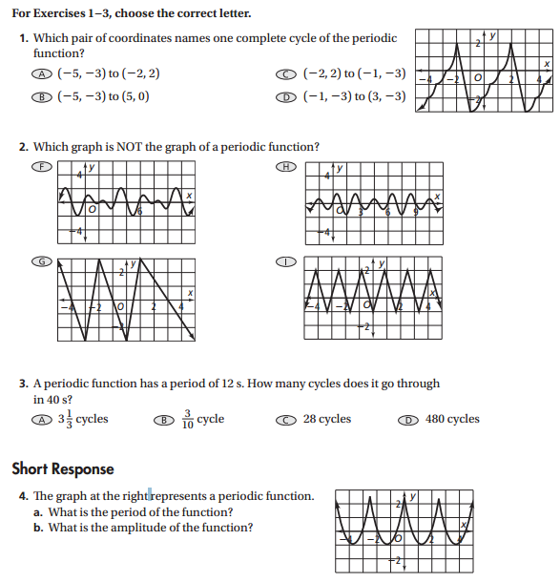

**Determine the number of cycles each sine function has in the interval from 0 to 2***π***. Find the amplitude and period of each function.**

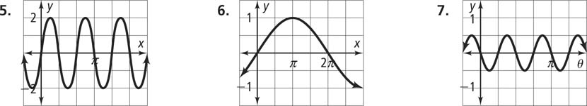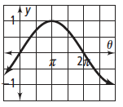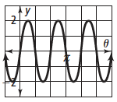**5. 6. 7.**

**Write an equation for each graph in the form y=asinbθ by finding the number of cycles (b).**

**8.** amplitude = 2

period =

**9.** amplitude = 2.5

period = 2*π*

**Find the amplitude, period, and midline of each sine curve. Then write an equation for each sine function.**

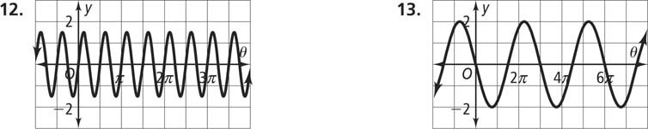**12. 13.**

**Determine the number of cycles each sine function has in the interval from 0 to 2**π**. Find the amplitude and period of each function.**

**14.** *y* = sin 2*θ*

**15.** *y* = −3 sin 2*θ*

**16.** *y* = 4 sin 5*θ*