Homework 8.5: The Unit Circle

Math 3

**Directions:** Fill out the blank unit circle below. Try your best to practice this without looking at your key! Use it to evaluate the expression on the backside.

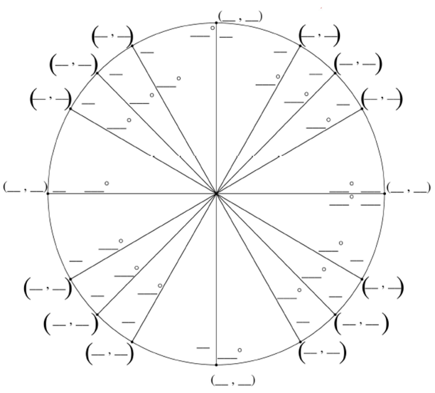

**Directions:** Complete the following tables. Show all work on a separate sheet of paper. If the angle measure is greater than 360° or 2π, find the positive coterminal angle between 0° and 360° first.

|  |  |  |  |  |  |  |  |  |
| --- | --- | --- | --- | --- | --- | --- | --- | --- |
| **Radian Measure** |  |  |  |  |  |  |  |  |
| **Degree Measure** | 480° | 330° | 135° | 450° | 30° | −135° | 900° | 240° |
| **Sin** |  | − |  | 1 |  | − | 0 | − |
| **Cos** | − |  | − | 0 |  | − | −1 | − |
| **Tan** | − | − | −1 | Undef. |  | 1 | 0 |  |
| **Cot** | − | − | −1 | 0 |  | 1 | Undef. |  |
| **Sec** | −2 |  | − | Undef. |  | − | −1 | −2 |
| **Csc** |  | −2 |  | 1 | 2 | − | Undef. | − |

|  |  |  |  |  |  |  |  |  |
| --- | --- | --- | --- | --- | --- | --- | --- | --- |
| **Radian Measure** |  |  |  |  |  |  |  |  |
| **Degree Measure** | −270° | 540° | −420° | 150° | 585° | −210° | 315° | 270° |
| **Sin** | 1 | 0 | − |  | − |  | − | −1 |
| **Cos** | 0 | −1 |  | − | − | − |  | 0 |
| **Tan** | Undef. | 0 | − | − | 1 | − | −1 | Undef. |
| **Cot** | 0 | Undef. | − | − | 1 | − | −1 | 0 |
| Sec | Undef. | −1 | 2 | − | − | − |  | Undef. |
| **Csc** | 1 | Undef. | − | 2 | − | 2 | − | −1 |