Homework 7.5: The Unit Circle Name: _______________________________

Math 3

**Directions:** Fill out the blank unit circle below. Try your best to practice this without looking at your key! Use it to evaluate the expression on the backside.

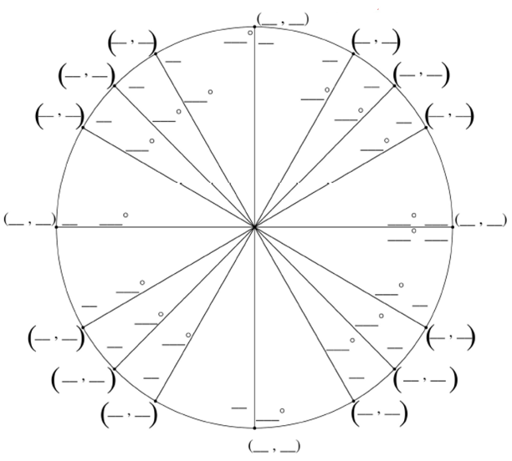

**Directions:** Complete the following tables. Show all work on a separate sheet of paper. If the angle measure is greater than 360° or 2π, find the positive coterminal angle between 0° and 360° first.

|  |  |  |  |  |  |  |  |  |
| --- | --- | --- | --- | --- | --- | --- | --- | --- |
| **Radian Measure** |  |  |  |  |  |  |  |  |
| **Degree Measure** |  | 330° |  | 450° |  | −135° |  | 240° |
| **Sin** |  |  |  |  |  |  |  |  |
| **Cos** |  |  |  |  |  |  |  |  |
| **Tan** |  |  |  |  |  |  |  |  |
| **Cot** |  |  |  |  |  |  |  |  |
| **Sec** |  |  |  |  |  |  |  |  |
| **Csc** |  |  |  |  |  |  |  |  |

|  |  |  |  |  |  |  |  |  |
| --- | --- | --- | --- | --- | --- | --- | --- | --- |
| **Radian Measure** |  |  |  |  |  |  |  |  |
| **Degree Measure** |  | 540° |  | 150° |  | −210° |  | 270° |
| **Sin** |  |  |  |  |  |  |  |  |
| **Cos** |  |  |  |  |  |  |  |  |
| **Tan** |  |  |  |  |  |  |  |  |
| **Cot** |  |  |  |  |  |  |  |  |
| Sec |  |  |  |  |  |  |  |  |
| **Csc** |  |  |  |  |  |  |  |  |