Homework 6.5: Parallelograms & Quadrilaterals Name: __________________________
Math 3

- Use the diagram below to solve for x and y if the figure is a parallelogram.

- PT = 2x, QT = y + 12,
TR = x + 2, TS = 7y
- PT = y, TR = 4y -15,
QT = x + 6, TS = 4x - 6

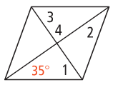
- Find the measure of each angle if the figure is a rhombus.

- Find the m∠1.
- Find the m∠2.

- Find the m∠3.
- Find the m∠4.

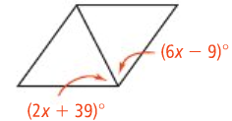
- Solve for x if the figure is a rhombus.
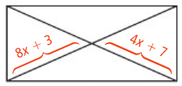
- Solve for x if the figure is a rectangle.

- What is the length of LN if the figure is a rectangle?
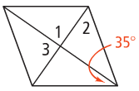
- Solve for the missing angle measures if the figure is a rhombus.

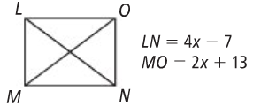

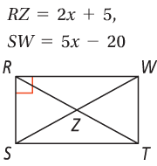
- What is the length of SW?
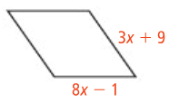
- Solve for x if the figure is a rhombus.

Directions: For questions #9-10, find x and the length of EF.

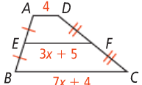
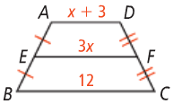

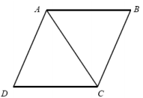
Proof #1:

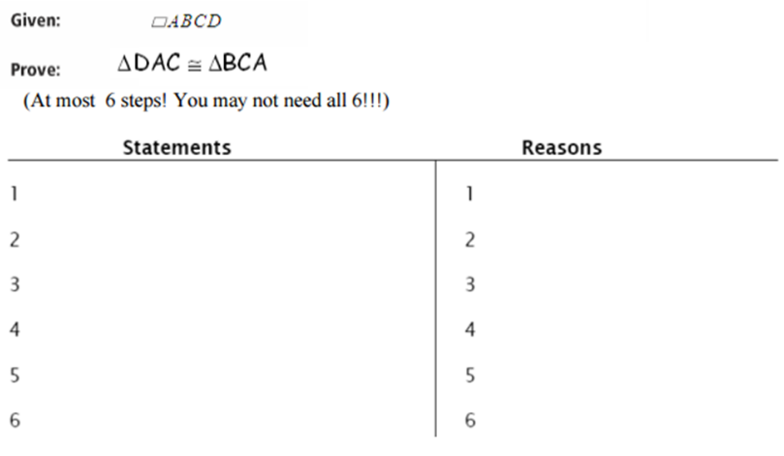

Proof #2:
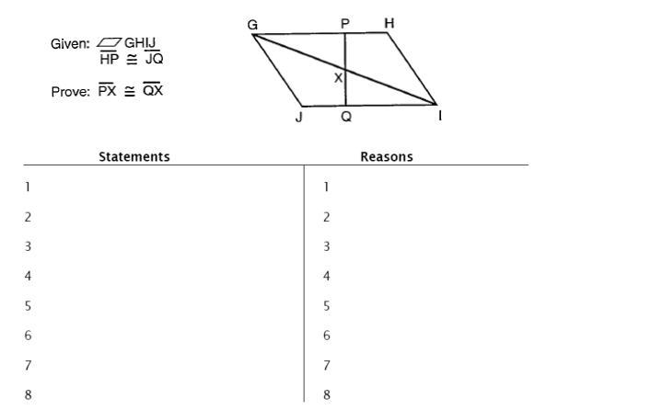

9 9

