Homework 6.4: Centers of Triangles Name: __________________________
Math 3

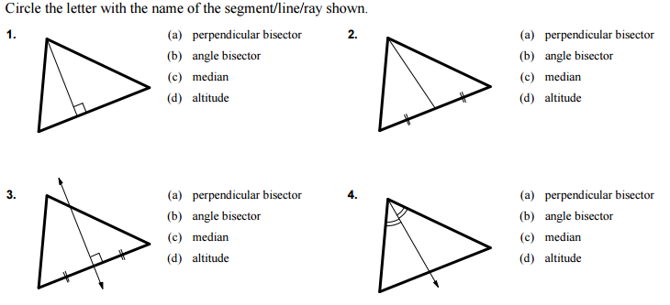

5. The three medians of a triangle intersect at the _______________________.
6. The three perpendicular bisectors of a triangle intersect at the _______________________.
7. The three angle bisectors of a triangle intersect at the _______________________.

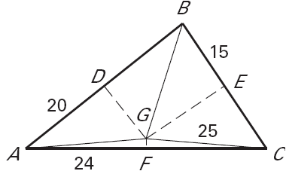
In the diagram, the perpendicular bisectors (shown with dashed segments) of ΔABC meet at point G--the circumcenter. and are shown dashed. Find the indicated measure.

8. AG = __________ 9. BD = __________ 10. CF = __________

11. AB = __________ 12. CE = __________ 13. AC = __________

14. m∠ADG = __________

15. IF BG = (2x – 15), find x = __________.

Point T is the incenter of ΔPQR.
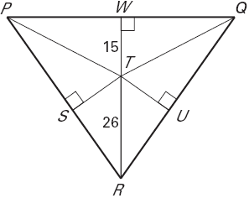
16. If Point T is the incenter, then Point T is the point of concurrency of
the ___________________________.

17. ST = __________

18. If TU = (2x – 1), find x = ________.

19. If m∠PRT = 24º, then m∠QRT = __________

20. If m∠RPQ = 62º, then m∠RPT = __________

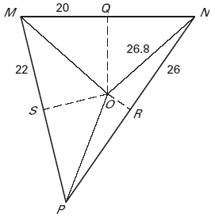
In the diagram, the perpendicular bisectors (shown with dashed segments) of MNP meet at point O—the circumcenter. Find the indicated measure.

21. MO = __________ 22. PR = __________ 23. MN = __________

24. SP = __________ 25. m∠MQO = __________

26. If OP = 2x, find x = ________.

Point G is the centroid of ∆ ABC, AD = 8, AG = 10, BE = 10, AC = 16 and CD = 18. Find the length of each segment.

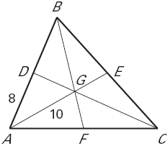
27. If Point G is the centroid, then Point G is the point of concurrency of the ___________________________.

28. DB = __________ 29. EA = __________ 30. CG = __________

31. BA = __________ 32. GE = __________ 33. GD = __________

34. BC = __________ 35. AF = __________

Point S is the centroid of ΔRTW, RS = 4, VW = 6, and TV= 9. Find the length of each segment.

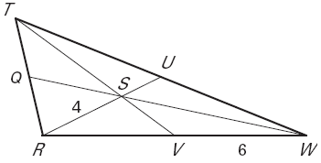
36. RV = __________ 37. SU = __________

38. RU = __________ 39. RW = __________

40. TS = __________ 41. SV = __________

Point G is the centroid of ∆ ABC. Use the given information to find the value of the variable.

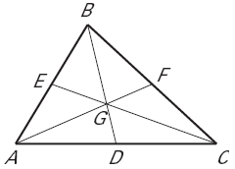
42. Find x if FG = x + 8 and GA = 6x – 4

43. Find y if CG = 3y + 7 and CE = 6y

