Homework 6.3: Similar Polygons Name: __________________________

Math 3

**Directions:** List the pairs of congruent angles and the extended proportion that relates the corresponding sides for the similar polygons.

1. *ABCD* ~ *WXYZ*
2. Δ*MNO* ~ Δ*RST*

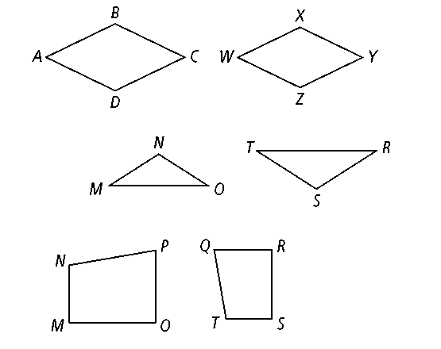

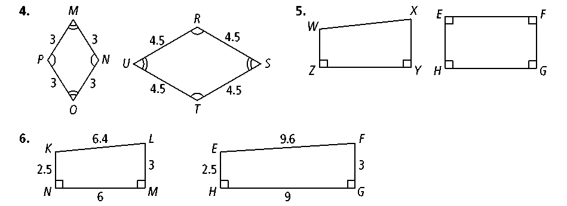**Directions:** Determine whether the polygons are similar. If so, write a similarity statement and give the scale factor. If not, explain.

1. 

.

**Directions:** Determine whether the polygons are similar.

1. An equilateral triangle with side length 6 and an equilateral triangle with side length 15
2. A triangle with side lengths 3 cm, 4 cm, and 5 cm, and a triangle with side lengths 18 cm, 19 cm, and 20 cm
3. A square with side length 4 and a rectangle with width 8 and length 8.5
4. A rhombus with side lengths 8 and consecutive angles 50º and 130 º, and a rhombus with side lengths 13 and consecutive angles 50º and 130º

**Directions:** In the diagram below, Δ*PRQ* ~ Δ*DEF.* Find each of the following.

1. 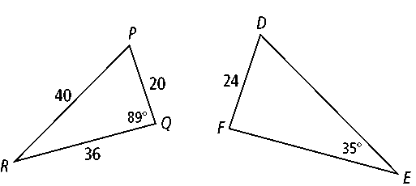the scale factor of Δ*PRQ* to Δ*DEF*
2. *m*∠*D*
3. *m*∠*R*
4. *m*∠*P*
5. *DE*
6. *FE*

**Directions:** Determine whether the triangles are similar. If so, write a similarity statement and name the postulate or theorem you used. If not, explain.

1. 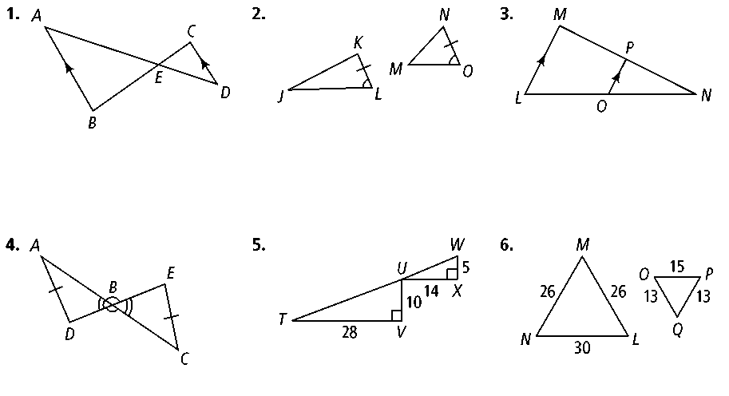
2. 
3. 

**Directions:** Prove each of the following. Be sure to create a two-column proof.

1. 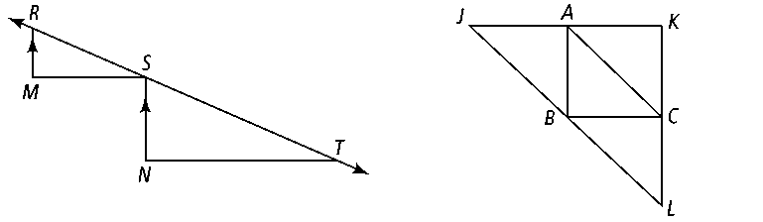**Given:** , 

**Prove:** Δ*RSM* ~ Δ*STN*



1. **Given:** *A* bisects, *C* bisects , *B* bisects 

**Prove:** Δ*JKL* ~ Δ*CBA*

1. A 1.4-m tall child is standing next to a flagpole. The child’s shadow is 1.2 m long. At the same time, the shadow of the flagpole is 7.5 m long. How tall is the flagpole?