Homework 6.1: Parallel Lines and Transversals Name: _____________________

**Directions:** Name each of the following types of angles. Then, state whether they are congruent or supplementary.

|  |  |  |  |
| --- | --- | --- | --- |
|  | Name: |  | Name: |
| Congruent  or  Supplementary | Congruent  or  Supplementary |
|  | Name: |  | Name: |
| Congruent  or  Supplementary | Congruent  or  Supplementary |

**Directions:** Find the value of x in each question given that lines *l* and *m* are parallel. Check your answers by finding the measure of each angle.

5.

6.

7.

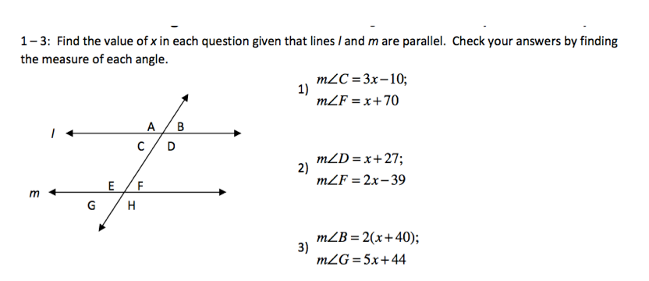

x =

m<D =

m<F =

x =

m<B =

m<G =

x =

m<C =

m<F =

**Directions:** Solve for the following. Show all work in the space provided.

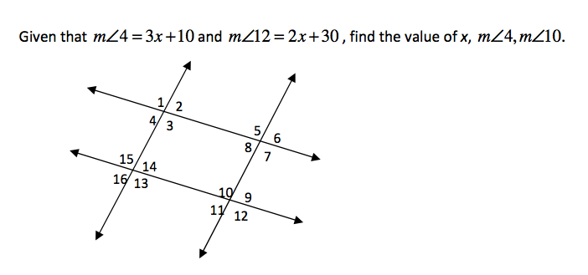

8.

**x =**

**m<4 =**

**m<10 =**



1. In the accompanying diagram, line ℓ is parallel to line *m*, and line *t* is a transversal. Which must be a true statement?

(1)  (3) 

(2)  (4) 



1. The accompanying diagram shows two parallel roads, Hope Street and Grand Street, crossed by a transversal road, Broadway. If  what is the measure of 

(1) 40° (3) 110°

(2) 70° (4) 180°

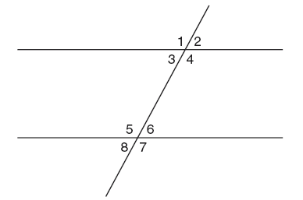

1. In the accompanying figure, what is one pair of alternate interior angles?

(1) 1 and 2 (3) 4 and 6

(2) 4 and 5 (4) 6 and 8

1. Find the value of x and y.

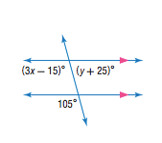

$$x =$$

$$y =$$