Homework 5.4: Solving Rational Equations Name: ______________________
Math 3

Directions: Decide whether each of the following is an expression or an equation. If it is an equation, solve it. If it is an expression, write it as a single fraction.
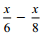
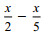

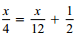
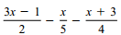
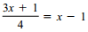

Directions: Solve each equation. Check for extraneous solutions.
