Homework 4.9: Writing Polynomials Name: _______________________
Math 3

Directions: State whether (x – 3) is a factor.

Directions: Write the polynomial function in standard form when given the leading coefficient and the zeros of the function.

 | Function: | Graph:  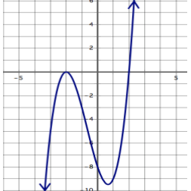
End Behavior:
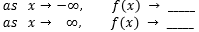

Roots (with Multiplicity):

Value of the leading coefficient:

Domain: Range:

Directions: Without using technology, sketch the graph of the polynomial function described.

- A cubic function with a leading coefficient of -2, with one positive zero.

- A quartic function with a leading coefficient of 1, with two double zeros.

- A cubic function with a leading coefficient of -3, with one positive triple root.

- A quartic function with a leading coefficient of -2, with two negative zeros and two complex (imaginary) roots.

Directions: Circle the expression that has the greatest value of f(x) as x ∞.

