Homework 4.8: Solving Polynomials Name: ___________________________
Math 3

Directions: Without using a calculator, find all linear factors and then determine all roots of the function. Sketch a graph with this information.

- f(x) = x³ – 5x² Factors: Roots: Graph:
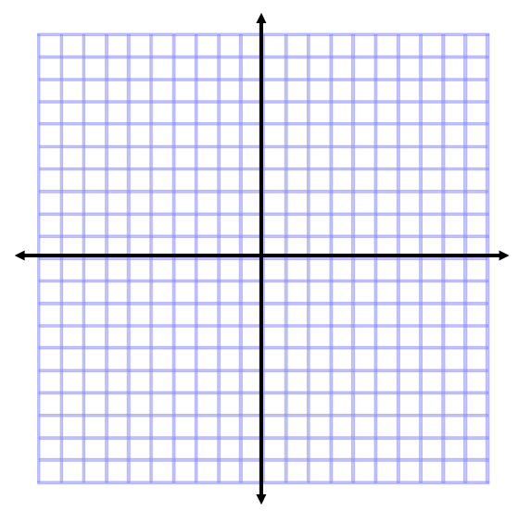

- f(x) = x⁴ - 16 Factors: Roots: Graph:

- f(x) = x³ – 2x² + 9x – 18 Factors: Roots: Graph:

Directions: Using the given factor, find all remaining factors and then determine all roots of the function. Sketch a graph with this information.

- f(x) = x³ + 5x² +2 x – 8 Factor: (x – 1) Roots: Graph:

- f(x) = x³ – 2x² + 9x – 18 Factor: (x – 2) Roots: Graph:

- f(x) = x³ – 19x – 30 Factor: (x + 3) Roots: Graph:

- f(x) = x³ – 2x + 1 Factor: (x – 1) Roots: Graph:
Hint: Use Quad Formula to solve for missing roots!

Directions: Solve for x.

- 2(x – 2)(x + 1)² = 0
- Log₂x = 4

- Log₂4 = x
- $\frac{1}{x}=6$

- X³ – 1 = 0 (Hint: Use SOAP to factor and Quadratic Formula to solve)

