Homework 4.4: Rates of Change Name: ______________________
Math 3

Directions: Order the following numbers from least to greatest.

- 100³ $\sqrt{100}$ log₂100 100 1. ________________________________

- 2⁻¹ $\sqrt{100}$ log₂(1/8) 0 2. ________________________________

- 2⁰ $\sqrt{16}$ log₂8 2 3. ________________________________

Directions: Which is greater? For each problem, make a true statement by placing the appropriate inequality symbol between the two expressions. (Hint: Think about what you know about the expression and the end behavior as well as rates of change of the function instead of plugging in values).

If x < -100, then: | If x > 100, then:
- x² _______ 2^{x} | - x² _______ 2^{x}
- x⁵ _______ x² | - x⁵ _______ x²
- x² _______ x³ | - x² _______ x³

Directions: Determine the function type and state the end behavior.

Directions: Use questions #10-13 to answer the following.

- Which function above has the greatest value at x = 1000? 14. ________________
- Which function above is always increasing? 15. ________________
- Which function above is always decreasing? 16. ________________
- Which function above has a relative maximum value? 17. ________________
Directions: Determine the end behavior.
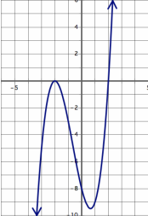

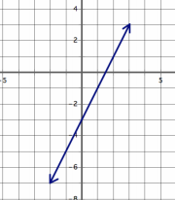

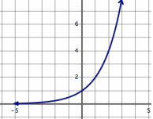

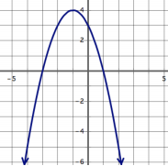
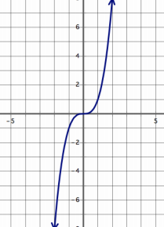
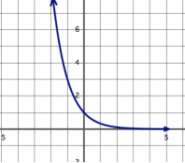

Review: Solve for x.

