Homework 4.3: Exploring Polynomials Name: ______________________
Math 3

Directions: Given each graph below, estimate the relative maxima/minima to the nearest tenth. Then, state the domain, range, the absolute maximums and minimums, and the intervals increasing and decreasing.

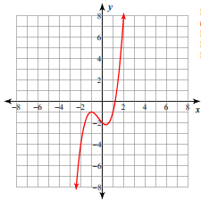
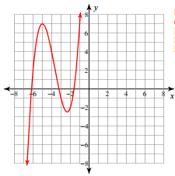

Relative Max: Relative Max:
Relative Min: Relative Min:
Absolute Max: Absolute Max:
Absolute Min: Absolute Min:
Domain: Domain:
Range: Range:
Interval Increase: Interval Increase:
Interval Decrease: Interval Decrease:

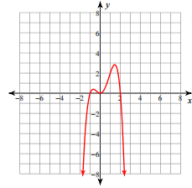
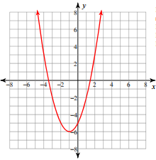

Relative Max: Relative Max:
Relative Min: Relative Min:
Absolute Max: Absolute Max:
Absolute Min: Absolute Min:
Domain: Domain:
Range: Range:
Interval Increase: Interval Increase:
Interval Decrease: Interval Decrease:
- An open box is to be made from a 2-foot by 3-foot rectangular piece of material by cutting equal squares from the corners and turning up the sides. Find the volume of the largest box that can be made in this manner.

- The number of bacteria in a refrigerated food is given by N(t) = 20t² – 20t + 120, for -2 < t < 14 and where t is the temperature of the food in Celsius. At what temperature will the number of bacteria be minimal?

- Find the number of units that produce the maximum revenue R = 900x – 0.1x², where R is the total revenue (in dollars) and x is the number of units sold.

Review: Divide each of the following.

8. 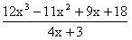
9. 