Homework 4.1: Combining Functions Name: ______________________
Math 3

Directions: Find the equation of the line f(x) and g(x) in the form y=mx + b by determining the slope and the y-intercept. Then, combine the functions in the following ways.

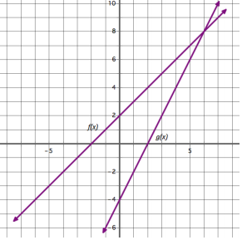
- Equation of f(x) =
- Equation of g(x) =

- f(x) + g(x) =
- f(x) – g(x) =

- f(x)•g(x) =

Directions: Use the given functions to solve questions 6-12.

f(x) = x – 3
g(x) = x + 2
h(x) = –x + 1
m(x) = x² + 3x + 2
n(x) = 2x³ –x² + 2x + 1
p(x) = 2x + 1

- f(x) + g(x)
- f(x) – h(x)
- f(x) + p(x)

- g(x) + h(x)
- m(x) – g(x)
- n(x) + m(x)

Directions: Determine if the statement is SOMETIMES, ALWAYS, or NEVER true.

- The sum of two linear functions is another linear function. 12. ____________________
- The sum of a linear and a quadratic is a cubic function. 13. ____________________
- The sum of the cubic and a quadratic function is a cubic function. 14. ____________________
Homework 4.2: Dividing Polynomials Name: _______________________
Math 3

Divide each of the polynomials using either long or synthetic division.

1. (4x² – 9) ÷ (2x + 3)
- 2. (x² – 4) ÷ (x + 4)

3. (2x² + 5x – 3) ÷ (x + 3)
4. (2x² + 5x – 3) ÷ (x – 3)

7. (11x + 20x² + 12x³ + 2) ÷ (3x + 2)
8. (12x³ + 2 + 11x + 20x²) ÷ (2x + 1)

9. 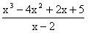
10. 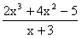

11. 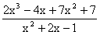
12. 