**Homework 3.7: Graphing Systems of Inequalities**

Directions: Match the system of inequalities to the correct graph.



 A) B) C) D)



E) F) G) H)

**Equations Answer Equations Answer**



1) 5)

____________ _____________

2) 6)

_____________ _____________



3) 7)

______________ ______________



4) 8)

______________ _______________

1. Which scenario can be modeled by the graph below?

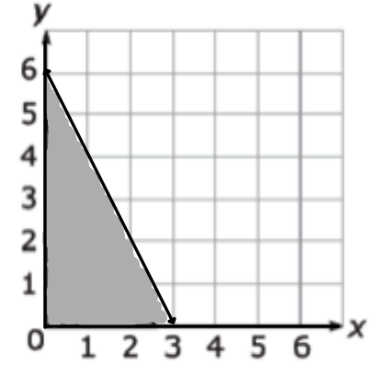

1. The number of pounds of coffee, y, minus two times the number of pounds of tea, y, is at most 6.
2. The number of pounds of coffee, y, minus half the number of pounds of tea, x, is at most 6.
3. The number of pounds of coffee, y, plus two times the number of pounds of tea, x , is at most 6.
4. The number of pounds of coffee, y, plus half the number of pounds of tea, x, is at most 6.

