Homework 3.6: Natural Logs & Base e Name: _________________________
Math 3

Directions: Expand each expression.

Directions: Solve each equation for x. Check your answer.
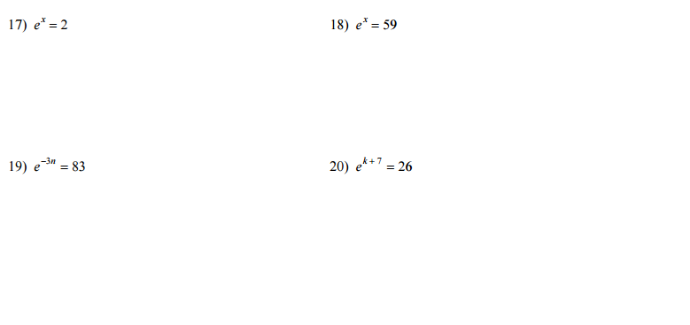
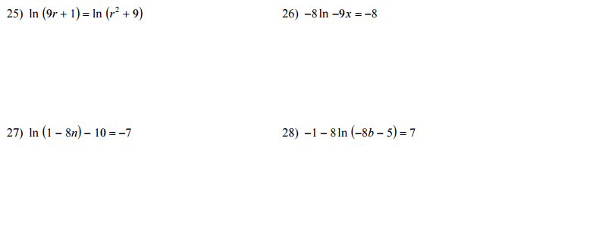
Directions: Write and solve an equation for each of the following. Show all work.

- A continuously compounded savings account had an initial deposit of $10,000.00 and 10 years later has a balance of $13,125.87. At what interest rate was the savings account?

- $250.00 is left in a savings account at 4.0% and the interest is compounded continuously. If the balance is now $330.78, then how many years was the money been in the account?

- Hearing about the PlayStation 4 release 3.5 years ago, a teenager put his savings of $500.00 into a continuously compounded savings account. He now has $619.65. At what fixed rate was the interest?

