Homework 3.4: Quiz Review Name: ___________________________

Math 3

**Write each equation in logarithmic form.**

**1.** 64 = 82 **2.** 8 = 23  **3.** 125 = 53 **4.** 729 = 36

**Evaluate each logarithm.**

**5.** log3 243 **6.** log5 625 **7.** log9 729 **8.** log4 256

**9. Reasoning** Find the value of log8 64 without using a calculator. Justify your answer.

**Write each expression as a single logarithm.**  
**10.** log53 + log56 **11.** log232 − log28 **12.** 

**Expand each logarithm.**  
**13.** **14.**  **15.** 

**Solve each equation.**

**16. **  **17.** 2 − 4*x* = −62 **18.** log *x* + log 2 = 5 **19.** log3 (*x* + 1) = 4

**20.** log 4*x* = −1 **21.** log 4 − log *x* = −2 **22.** 4 + 5*x* = 29 **23.** log(2x) = log (10)

**24.** 4*x* = 16 **25.** 9*y*−3 = 8 **26.**  **27.** *2 =* log 4 (*x +* 1)

**28.** You can use the equation *N =* *k* log *A* to estimate the number of species *N* that live in a region of area *A*. The parameter *k* is determined by the conditions in the region. In a rain forest, 2700 species live in 500 km2. How many species would remain if half of the forest area were destroyed by logging and farming?

**29. $f^{-1}\left(x\right)=\log\left(x+1\right)-2$ $f(x)= 2^{x+1}$ $f^{-1}(x)=$**

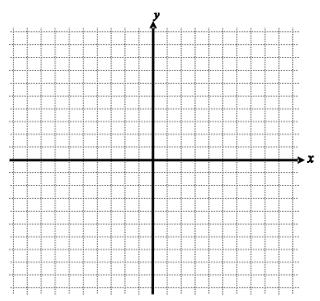

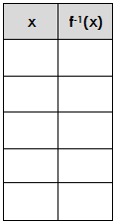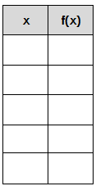

Transformations:

Asymptote:

Domain:

Range: