Homework 3.1: Intro to Logarithms Name: _______________________
Math 3

Directions: Write each equation in logarithmic form.

Directions: Write each equation in exponential form.

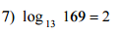
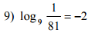

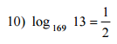
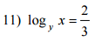
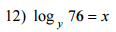

Directions: Evaluate each logarithm.

Directions: Solve each equation below. Show all work in the space provided.

