Homework 2.7: Inverse Relations (Equations) Name: ______________________
Math 3

Directions: Find the inverse function. Be sure to write the inverse as f⁻¹(x) =

- 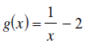
- 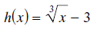

- 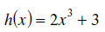

- 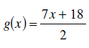

Homework 2.8: Verifying Inverse Relations Name: ______________________
Math 3

Directions: State if the given functions are inverses. Show all work.
